**A Mini Project Report**   
 **On**

**EVENT MANAGEMENT WEBSITE**



**Submitted By**

**M.RAMYA**  
 **Regd. Number:23B91A61C3**

**DEPARTENGINEERING**

**S. R. K. R ENGINEERING COLLEGE (A)**   
 **(Affiliated to JNTU, KAKINADA)**   
 **BHIMAVARAM-534204**   
 **(2022-2023)**

**DEPARTMENT OF COMPUTER SCIENCE AND ENGINEERING S. R. K. R ENGINEERING COLLEGE BHIMAVARAM**   
 1



***CERTIFICATE***

This is to certify that this is a bonafide work on “**ONLINE CRICKET WEBSITE**” for and has been submitted by Mr. Davuluri Divakar(**20B91A0571**) as a **Web Application Development Using Full Stack** laboratory report, in partial fulfilment of the requirements for theaward of the Degree of Bachelor of Technology in Computer Science and Engineering, during the academic year 2022-2023. The candidate worked right under my Supervision and guidance.

**Lecturers In-Charge**

K .D.V.PAVAN KUMAR VARMA

CH Vinod Varma   
S Suryanarayana Raju Assistant professor,

**Head of the Department**   
Dr. V. CHANDRA SHEKHAR   
Head of the Department,

Department of CSE, Department of CSE,

S.R.K.R. Engineering College, Bhimavaram. Bhimavaram

2

**ACKNOWLEDGEMENT**

I take immense pleasure in thanking **Dr. M. Jagapathi Raju,** beloved principal of S.R.K.R Engineering College, Bhimavaram, and **Dr. V. Chandra Shekar,** esteemed **Head of the Department** (C.S.E), for having permitted me to carry out this Web Application Development Using Full Stack mini project work.

I wish to express my deep sense of gratitude especially to my project Guide**, Sri. K D V PAVAN KUMAR VARMA, Assistant Professor, Sri Ch Vinod Varma, Assistant Professor, Sri S Suryanarayana Raju, Assistant Professor,** for their guidance and useful suggestions, which helped me in completing the project work, on time.

Finally, yet importantly, I would like to express my heartful thanks to my beloved parents, faculty, my friends/classmates for their help, and my wishes for the successful completion of this project.

Davuluri. Divakar (20B91A0571)

3

**TABLE OF CONTENT**

|  |  |  |
| --- | --- | --- |
| **S. No** | **CONTENTS** | **Page. No** |
| 1. | ABSTRACT | 5 |
| 2. | MODULES | 5 |
| 3. | SOFTWARE REQUIREMENTS | 5 |
| 4. | HARDWARE REQUIREMENTS | 5 |
| 5. | TECHNICAL STACK | 5 |
| 6. | SAMPLE CODE | 6-11 |
| 7. | SCREENSHOTS | 12-30 |
| 8. | LAB PROGRAMS | 31 |

4

ABSTRACT

The **Student Event Management Website** is a dynamic web-based platform designed to streamline the organization, management, and participation of student events within a college or university setting. This project addresses the common challenges faced in managing campus events such as registrations, event updates, and communication between students and organizers.

Built using HTML, CSS, and JavaScript for the frontend, the platform offers a user-friendly interface where students can browse upcoming events, register for   
participation, and receive real-time updates. Event administrators are provided with dedicated access to create, update, and manage events efficiently.

The system promotes digital transformation in student engagement by reducing manual work, enhancing communication, and ensuring transparent participation tracking. This website is especially beneficial during large college fests, technical symposiums, and cultural activities, offering a centralized hub for all event- related interactions.

The project not only demonstrates practical web development skills but also aims to improve the overall student experience through technology-driven event coordination.

5

MODULES

• Register for event page

• About page

• Admin dashboard page

• Contact page

• Dashboard register page

• event-details page

• Events page

• Login page

• Register page

• registration-confirmation page

• Services page

• Signup page

• User dashboard page

• users page

6

SOFTWARE REQUIRMENTS   
Text Editor: Visual Studio Code   
 1.Front End: HTML,CSS,JavaScript   
 2.Internet Browser: Google Chrome/Internet Browser

HARDWARE REQUIREMENTS   
 1.Processor-Intel Core I5   
 RAM-8GB

7

**TECHNICAL STACK**

**HTML**

(HyperText Markup Language)

HTML is the backbone of the website. It is used to structure the content on web pages. In this project, HTML was used to design the layout of various sections such as the homepage, event cards, registration form, navigation bar, and footer. Elements like headings, paragraphs, buttons, and images are all defined using HTML tags. It ensures semantic structure and content visibility on browsers.

CSS

(Cascading Style Sheets)

CSS is used to style and visually enhance the HTML elements. It controls the layout, color schemes, spacing, font styles, and responsiveness of the website. In this project, CSS was used to design visually appealing event cards, align content using Flexbox and Grid systems, apply transitions for hover effects, and ensure the website looks consistent across different devices.

JAVA SCRIPT

JavaScript brings interactivity to the website. It is a scripting language that allows dynamic content updates, user interaction handling, and input validation. In this project, JavaScript is used for form validation, displaying confirmation alerts when users register for events, toggling modals/popups for event details, and simulating admin actions like editing or deleting event cards without needing a backend.

8

**SAMPLE CODE**

**1. Main.html:**

<!DOCTYPE html> <!DOCTYPE html>   
<html lang="en">   
<head>   
 <meta charset="UTF-8">   
 <meta name="viewport" content="width=device-width, initial-scale=1.0"> <title>College Events - Login</title>   
 <link rel="stylesheet" href="../assets/css/style.css">   
 <link   
href="https://fonts.googleapis.com/css2?family=Montserrat:wght@400;500;600;700&d isplay=swap" rel="stylesheet">   
 <link rel="stylesheet" href="https://cdnjs.cloudflare.com/ajax/libs/font- awesome/6.0.0-beta3/css/all.min.css">   
 <style>   
 /* Login Hero Banner Styles */   
 .login-hero {   
 position: relative;   
 background: linear-gradient(rgba(0, 0, 0, 0.6), rgba(0, 0, 0, 0.6)), url('https://images.unsplash.com/photo-1531058020387-3be344556be6?ixlib=rb- 1.2.1&auto=format&fit=crop&w=1950&q=80');   
 background-size: cover;   
 background-position: center;   
 height: 300px;   
 display: flex;   
 align-items: center;   
 justify-content: center;   
 color: white;   
 text-align: center;   
 overflow: hidden;   
 margin-top: 70px;   
 }

.login-hero-content {   
 position: relative;   
 z-index: 2;   
 max-width: 800px;   
 padding: 0 20px;   
}

.login-hero h1 {   
 font-size: 48px;

9

font-weight: 700;   
 margin-bottom: 20px;   
 text-shadow: 2px 2px 4px rgba(0, 0, 0, 0.5); }

/* Login Container Styles */   
.login-container {   
 max-width: 1200px;   
 margin: 60px auto;   
 padding: 0 20px;   
 display: flex;   
 justify-content: center;   
}

.login-box {   
 background: var(--white);   
 padding: 40px;   
 border-radius: 8px;   
 box-shadow: 0 5px 15px rgba(0, 0, 0, 0.05); width: 100%;   
 max-width: 500px;   
}

.login-tabs {   
 display: flex;   
 margin-bottom: 30px;   
 border-bottom: 1px solid var(--border-color); }

.login-tab {   
 padding: 15px 30px;   
 cursor: pointer;   
 font-weight: 600;   
 color: var(--text-light);   
 position: relative;   
 transition: all 0.3s ease;   
}

.login-tab.active {   
 color: var(--primary-blue);   
}

.login-tab.active::after {   
 content: '';

10

position: absolute;   
 bottom: -1px;   
 left: 0;   
 width: 100%;   
 height: 2px;   
 background-color: var(--primary-blue);   
}

.form-group {   
 margin-bottom: 25px;   
}

.form-group label {   
 display: block;   
 margin-bottom: 8px;   
 font-weight: 600;   
 font-size: 0.9rem;   
 color: var(--text-dark);   
}

.form-group input {   
 width: 100%;   
 padding: 12px 15px;   
 border: 1px solid var(--border-color);   
 border-radius: 4px;   
 font-size: 1rem;   
 transition: border 0.3s ease;   
}

.form-group input:focus {   
 outline: none;   
 border-color: var(--primary-blue);   
 box-shadow: 0 0 0 2px var(--light-blue); }

.remember-forgot {   
 display: flex;   
 justify-content: space-between;   
 align-items: center;   
 margin-bottom: 25px;   
 font-size: 0.9rem;   
}

.remember-me {

11

display: flex;   
 align-items: center;   
}

.remember-me input {   
 margin-right: 8px;   
 accent-color: var(--primary-blue);   
}

.forgot-password a {   
 color: var(--primary-blue);   
 text-decoration: none;   
 transition: color 0.3s;   
}

.forgot-password a:hover {   
 text-decoration: underline;   
}

.submit-btn {   
 width: 100%;   
 padding: 14px;   
 background-color: var(--primary-blue); color: var(--white);   
 border: none;   
 border-radius: 4px;   
 font-size: 1rem;   
 font-weight: 600;   
 cursor: pointer;   
 transition: background-color 0.3s ease; text-transform: uppercase;   
 letter-spacing: 1px;   
}

.submit-btn:hover {   
 background-color: var(--dark-blue);   
}

.signup-link {   
 text-align: center;   
 margin-top: 20px;   
 font-size: 0.9rem;   
 color: var(--text-light);   
}

12

.signup-link a {   
 color: var(--primary-blue);   
 text-decoration: none;   
 font-weight: 600;   
 transition: color 0.3s;   
}

.signup-link a:hover {   
 text-decoration: underline;   
}

/* Responsive Styles for Login Components */   
@media (max-width: 768px) {   
.login-hero h1 {   
 font-size: 36px;   
 }

.login-box {   
 padding: 30px 20px;   
 }   
 }   
 </style>   
</head>   
<body>   
 <!-- Navigation -->   
 <nav>   
 <div class="logo">   
 <a href="../index.html">CollegeEvents</a>   
 </div>   
 <ul class="nav-links">   
 <li><a href="../index.html">Home</a></li>   
 <li><a href="about.html">About</a></li>   
 <li><a href="events.html">Events</a></li>   
 <li><a href="contact.html">Contact</a></li>   
 <li><a href="login.html" class="login-btn active">Login</a></li> </ul>   
 <div class="burger">   
 <i class="fas fa-bars"></i>   
 </div>   
 </nav>

<!-- Login Hero Banner -->   
<section class="login-hero">

13

<div class="login-hero-content">   
 <h1>Login to Your Account</h1>   
 </div>   
</section>

<!-- Login Container -->   
<section class="login-container">   
 <div class="login-box">   
 <div class="login-tabs">   
 <div class="login-tab active" id="user-tab">User Login</div> <div class="login-tab" id="admin-tab">Admin Login</div> </div>

<form class="login-form" id="loginForm">   
 <div class="form-group">   
 <label for="email">Email Address</label> <input type="email" id="email" name="email" placeholder="Enter your email" required>   
 </div>

<div class="form-group">   
 <label for="password">Password</label>   
 <input type="password" id="password" name="password" placeholder="Enter your password" required>   
</div>

<div class="remember-forgot">   
 <div class="remember-me">   
 <input type="checkbox" id="remember" name="remember"> <label for="remember">Remember me</label>   
 </div>   
 <div class="forgot-password">   
 <a href="#">Forgot password?</a>   
 </div>   
</div>

<button type="submit" class="submit-btn" id="loginButton">Login</button>

<div class="signup-link">   
 Don't have an account? <a href="../pages/signup.html">Sign up</a>   
 </div>   
 </form>

14

</div>   
</section>

<!-- Footer -->   
 <footer>   
 <div class="footer-content">   
 <div class="footer-section">   
 <h3>CollegeEvents</h3>   
 <p>Your one-stop platform for all college events and activities.</p>   
 <div class="social-icons">   
 <a href="#"><i class="fab fa-facebook-f"></i></a> <a href="#"><i class="fab fa-twitter"></i></a>   
 <a href="#"><i class="fab fa-instagram"></i></a> <a href="#"><i class="fab fa-linkedin-in"></i></a> </div>   
 </div>   
 <div class="footer-section">   
 <h3>Quick Links</h3>   
 <ul>   
 <li><a href="index.html">Home</a></li>   
 <li><a href="events.html">Events</a></li>   
 <li><a href="about.html">About</a></li>   
 <li><a href="contact.html">Contact</a></li>   
 <li><a href="login.html">Login</a></li>   
 </ul>   
 </div>   
 <div class="footer-section">   
 <h3>Contact Us</h3>   
 <li><i class="fas fa-map-marker-alt"></i> SRKR Engineering College, Chinnamiram, Bhimavaram, Chinamiram Rural, Andhra Pradesh 534204, India</li>

<p><i class="fas fa-phone"></i>6301726462</p>   
 <p><i class="fas fa-envelope"></i> srkrec@collegeevents.com</p> </div>   
 </div>   
 <div class="footer-bottom">   
 <p>&copy; 2025 CollegeEvents. All rights reserved.</p>   
 </div>   
</footer>

<script>   
 document.addEventListener('DOMContentLoaded', function() {

15

// Mobile menu toggle   
const burger = document.querySelector('.burger'); const navLinks = document.querySelector('.nav-links');

burger.addEventListener('click', function() {   
navLinks.classList.toggle('nav-active');   
});

// Login tabs functionality   
const userTab = document.getElementById('user-tab');   
const adminTab = document.getElementById('admin-tab'); const loginForm = document.getElementById('loginForm'); const loginButton = document.getElementById('loginButton');

let currentLoginType = 'user';

// Tab switching   
userTab.addEventListener('click', function() {   
userTab.classList.add('active');   
adminTab.classList.remove('active');   
currentLoginType = 'user';   
loginButton.textContent = 'User Login';   
});

adminTab.addEventListener('click', function() {   
adminTab.classList.add('active');   
userTab.classList.remove('active');   
currentLoginType = 'admin';   
loginButton.textContent = 'Admin Login';   
});

// Form submission   
loginForm.addEventListener('submit', function(e) { e.preventDefault();

const email = document.getElementById('email').value; const password = document.getElementById('password').value;

if (!email || !password) {   
 alert('Please fill in all fields');   
 return;   
} if (currentLoginType === 'admin') {   
// Check for admin credentials (demo purposes only) if (email === 'admin@example.com' && password ===

window.location.href = 'admindashboard.html';   
} else {   
alert('Invalid admin credentials. Try admin@example.com

16

{

user123');

}   
} else {   
// Check for user credentials (demo purposes only)   
if (email === 'user@example.com' && password === 'user123')

window.location.href = 'userdashboard.html';   
} else {   
alert('Invalid user credentials. Try user@example.com /

}   
}   
});

});

// Demo credentials for testing   
// You can remove these in production document.getElementById('email').value = 'user@example.com'; document.getElementById('password').value = 'user123';

</script>   
</body>   
</html>

<html lang="en">   
<head>   
<meta charset="UTF-8">   
<meta name="viewport" content="width=device-width, initial-scale=1.0">   
<title>College Events - Login</title>   
<link rel="stylesheet" href="../assets/css/style.css">   
<link href="https://fonts.googleapis.com/css2?family=Montserrat:wght@400;500;600;700&d isplay=swap" rel="stylesheet">   
<link rel="stylesheet" href="https://cdnjs.cloudflare.com/ajax/libs/font-   
awesome/6.0.0-beta3/css/all.min.css">   
<style>

17

/* Login Hero Banner Styles */   
.login-hero {

position: relative;   
 background: linear-gradient(rgba(0, 0, 0, 0.6), rgba(0, 0, 0, 0.6)), url('https://images.unsplash.com/photo-1531058020387-3be344556be6?ixlib=rb- 1.2.1&auto=format&fit=crop&w=1950&q=80');   
 background-size: cover;   
 background-position: center;   
 height: 300px;   
 display: flex;   
 align-items: center;   
 justify-content: center;   
 color: white;   
 text-align: center;   
 overflow: hidden;   
 margin-top: 70px;   
 }

.login-hero-content {   
 position: relative;   
 z-index: 2;   
 max-width: 800px;   
 padding: 0 20px;   
}

.login-hero h1 {   
 font-size: 48px;   
 font-weight: 700;   
 margin-bottom: 20px;   
 text-shadow: 2px 2px 4px rgba(0, 0, 0, 0.5); }

/* Login Container Styles */   
.login-container {   
 max-width: 1200px;   
 margin: 60px auto;   
 padding: 0 20px;   
 display: flex;   
 justify-content: center;   
}

.login-box {   
background: var(--white);   
padding: 40px;   
border-radius: 8px;   
box-shadow: 0 5px 15px rgba(0, 0, 0, 0.05);

18

max-width: 500px;   
}

.login-tabs {   
 display: flex;   
 margin-bottom: 30px;   
 border-bottom: 1px solid var(--border-color); }

.login-tab {   
 padding: 15px 30px;   
 cursor: pointer;   
 font-weight: 600;   
 color: var(--text-light);   
 position: relative;   
 transition: all 0.3s ease;   
}

.login-tab.active {   
 color: var(--primary-blue);   
}

.login-tab.active::after {   
 content: '';   
 position: absolute;   
 bottom: -1px;   
 left: 0;   
 width: 100%;   
 height: 2px;   
 background-color: var(--primary-blue); }

.form-group {   
 margin-bottom: 25px;   
}

.form-group label {   
 display: block;   
 margin-bottom: 8px;   
 font-weight: 600;   
 font-size: 0.9rem;   
 color: var(--text-dark);   
}

19

width: 100%;   
 padding: 12px 15px;   
 border: 1px solid var(--border-color); border-radius: 4px;   
 font-size: 1rem;   
 transition: border 0.3s ease;   
}

.form-group input:focus {   
 outline: none;   
 border-color: var(--primary-blue);   
 box-shadow: 0 0 0 2px var(--light-blue); }

.remember-forgot {   
 display: flex;   
 justify-content: space-between;   
 align-items: center;   
 margin-bottom: 25px;   
 font-size: 0.9rem;   
}

.remember-me {   
 display: flex;   
 align-items: center;   
}

.remember-me input {   
 margin-right: 8px;   
 accent-color: var(--primary-blue); }

.forgot-password a {   
 color: var(--primary-blue);   
 text-decoration: none;   
 transition: color 0.3s;   
}

.forgot-password a:hover {   
 text-decoration: underline;   
}

.submit-btn {

20

background-color: var(--primary-blue); color: var(--white);   
border: none;   
border-radius: 4px;   
font-size: 1rem;   
font-weight: 600;   
cursor: pointer;   
transition: background-color 0.3s ease; text-transform: uppercase;   
letter-spacing: 1px;   
}

.submit-btn:hover {   
background-color: var(--dark-blue);   
}

.signup-link {   
text-align: center;   
margin-top: 20px;   
font-size: 0.9rem;   
color: var(--text-light);   
}

.signup-link a {   
color: var(--primary-blue);   
text-decoration: none;   
font-weight: 600;   
transition: color 0.3s;   
}

.signup-link a:hover {   
text-decoration: underline;   
}

/* Responsive Styles for Login Components */ @media (max-width: 768px) {   
 .login-hero h1 {   
 font-size: 36px;   
 }

.login-box {   
 padding: 30px 20px;   
}   
}

21

</head>   
<body>   
 <!-- Navigation -->   
 <nav>   
 <div class="logo">   
 <a href="../index.html">CollegeEvents</a>   
 </div>   
 <ul class="nav-links">   
 <li><a href="../index.html">Home</a></li>   
 <li><a href="about.html">About</a></li>   
 <li><a href="events.html">Events</a></li>   
 <li><a href="contact.html">Contact</a></li>   
 <li><a href="login.html" class="login-btn active">Login</a></li> </ul>   
 <div class="burger">   
 <i class="fas fa-bars"></i>   
 </div>   
 </nav>

<!-- Login Hero Banner -->   
<section class="login-hero">   
 <div class="login-hero-content">   
 <h1>Login to Your Account</h1>   
 </div>   
</section>

<!-- Login Container -->   
<section class="login-container">   
 <div class="login-box">   
 <div class="login-tabs">   
 <div class="login-tab active" id="user-tab">User Login</div> <div class="login-tab" id="admin-tab">Admin Login</div> </div>

<form class="login-form" id="loginForm">   
 <div class="form-group">   
 <label for="email">Email Address</label> <input type="email" id="email" name="email" placeholder="Enter your email" required>   
 </div>

<div class="form-group">   
 <label for="password">Password</label>

22

</div>

<div class="remember-forgot">   
 <div class="remember-me">   
 <input type="checkbox" id="remember" name="remember"> <label for="remember">Remember me</label>   
 </div>   
 <div class="forgot-password">   
 <a href="#">Forgot password?</a>   
 </div>   
</div>

<button type="submit" class="submit-btn" id="loginButton">Login</button>

<div class="signup-link">   
 Don't have an account? <a href="../pages/signup.html">Sign up</a>   
 </div>   
 </form>   
 </div>   
 </section>

<!-- Footer -->   
 <footer>   
 <div class="footer-content">   
 <div class="footer-section">   
 <h3>CollegeEvents</h3>   
 <p>Your one-stop platform for all college events and activities.</p>   
 <div class="social-icons">   
 <a href="#"><i class="fab fa-facebook-f"></i></a> <a href="#"><i class="fab fa-twitter"></i></a> <a href="#"><i class="fab fa-instagram"></i></a> <a href="#"><i class="fab fa-linkedin-in"></i></a>

|  |  |
| --- | --- |
| </div> | 23 |

</ul>   
 </div>   
 <div class="footer-section">   
 <h3>Contact Us</h3>   
 <li><i class="fas fa-map-marker-alt"></i> SRKR Engineering College, Chinnamiram, Bhimavaram, Chinamiram Rural, Andhra Pradesh 534204, India</li>

<p><i class="fas fa-phone"></i>6301726462</p>   
 <p><i class="fas fa-envelope"></i> srkrec@collegeevents.com</p> </div>   
 </div>   
 <div class="footer-bottom">   
 <p>&copy; 2025 CollegeEvents. All rights reserved.</p>   
 </div>   
</footer>

<script>   
 document.addEventListener('DOMContentLoaded', function() { // Mobile menu toggle   
 const burger = document.querySelector('.burger'); const navLinks = document.querySelector('.nav-links');

burger.addEventListener('click', function() { navLinks.classList.toggle('nav-active'); });

// Login tabs functionality   
const userTab = document.getElementById('user-tab');   
const adminTab = document.getElementById('admin-tab'); const loginForm = document.getElementById('loginForm'); const loginButton = document.getElementById('loginButton');

let currentLoginType = 'user';

// Tab switching   
userTab.addEventListener('click', function() { userTab.classList.add('active');   
adminTab.classList.remove('active');   
currentLoginType = 'user';   
loginButton.textContent = 'User Login'; }); 24

userTab.classList.remove('active');   
currentLoginType = 'admin';   
loginButton.textContent = 'Admin Login';

});

// Form submission   
loginForm.addEventListener('submit', function(e) { e.preventDefault();

const email = document.getElementById('email').value; const password = document.getElementById('password').value;

if (!email || !password) {   
 alert('Please fill in all fields');   
 return;   
}

// Simple validation (in a real app, you would verify   
credentials with a server)   
if (currentLoginType === 'admin') {   
 // Check for admin credentials (demo purposes only) if (email === 'admin@example.com' && password ===   
'admin123') {   
 window.location.href = 'admindashboard.html';   
 } else {   
 alert('Invalid admin credentials. Try admin@example.com/ admin123');

}   
} else {   
 // Check for user credentials (demo purposes only)   
 if (email === 'user@example.com' && password === 'user123') {   
 window.location.href = 'userdashboard.html';   
 } else {   
 alert('Invalid user credentials. Try user@example.com / user123');

}   
} 25   
});

// Demo credentials for testing

in production document.getElementById('email').value = 'user@example.com';

document.getElementById('password').value = 'user123';

</script>   
</body>   
</htm

**events.html**

<!DOCTYPE html>   
<html lang="en">   
<head>   
 <meta charset="UTF-8">   
 <meta name="viewport" content="width=device-width, initial-scale=1.0">   
 <title>Events - College Events</title>   
 <link rel="stylesheet" href="../assets/css/events.css">   
 <link   
href="https://fonts.googleapis.com/css2?family=Montserrat:wght@400;500;600;700&display =swap" rel="stylesheet">   
 <link rel="stylesheet" href="https://cdnjs.cloudflare.com/ajax/libs/font-  
awesome/6.0.0-beta3/css/all.min.css">   
</head>   
<body>   
 <!-- Navigation -->   
 <nav>   
 <div class="logo">   
 <a href="../index.html">CollegeEvents</a>   
 </div>   
 <ul class="nav-links">   
 <li><a href="../index.html">Home</a></li>   
 <li><a href="about.html">About</a></li>   
 <li><a href="events.html" class="active">Events</a></li>   
 <li><a href="contact.html">Contact</a></li>   
 <li><a href="login.html" class="login-btn">Login</a></li>   
 </ul>   
 <div class="burger">   
 <i class="fas fa-bars"></i>   
 </div>   
 </nav>

<!-- Events Hero Section -->   
 <section class="page-hero" style="background-image: linear-  
gradient(rgba(0,0,0,0.6), rgba(0,0,0,0.6)), url('https://images.unsplash.com/photo-1492684223066-81342ee5ff30');">   
 <div class="hero-content">   
 <h1>Upcoming College Events</h1>   
 <p>Discover and attend the most exciting events happening on campus</p> </div>   
 </section>

26

<!-- Events Filter -->   
 <section class="events-filter">   
 <div class="container">   
 <div class="filter-options">   
 <div class="filter-group">   
 <label for="event-category">Category</label>   
 <select id="event-category">   
 <option value="all">All Categories</option>   
 <option value="academic">Academic</option>   
 <option value="cultural">Cultural</option>   
 <option value="sports">Sports</option>   
 <option value="career">Career</option>   
 <option value="social">Social</option>   
 </select>   
 </div>   
 <div class="filter-group">   
 <label for="event-date">Date</label>   
 <select id="event-date">   
 <option value="all">All Dates</option>   
 <option value="today">Today</option>   
 <option value="tomorrow">Tomorrow</option>   
 <option value="this-week">This Week</option>   
 <option value="this-month">This Month</option>   
 </select>   
 </div>   
 <div class="filter-group">   
 <label for="event-location">Location</label>   
 <select id="event-location">   
 <option value="all">All Locations</option>   
 <option value="campus-center">Campus Center</option> <option value="student-union">Student Union</option> <option value="sports-complex">Sports Complex</option> <option value="main-auditorium">Main Auditorium</option> </select>   
 </div>   
 <div class="filter-group">   
 <button id="filter-button" class="filter-btn">Apply   
Filters</button>   
 </div>   
 </div>   
 <div class="search-box">   
 <input type="text" placeholder="Search events...">   
 <button><i class="fas fa-search"></i></button>   
 </div>   
 </div>   
 </section>

<!-- Events List -->   
 <section class="events-list">   
 <div class="container">   
 <!-- Event 1 -->   
 <div class="event-card">

27

<div class="event-image">   
 <img src="../images/crux.jpg" alt="CRUX-2k25">   
 <div class="event-date">   
 <span class="day">4</span>   
 <span class="month">APR</span>   
 </div>   
 </div>   
 <div class="event-details">   
 <div class="event-category">   
 <span class="badge academic">Academic</span>   
 </div>   
 <h3><a href="my-events.html">CRUX-2k25</a></h3>   
 <div class="event-meta">   
 <span><i class="fas fa-clock"></i> 9:30 AM - 5:00 PM</span> <span><i class="fas fa-map-marker-alt"></i> Department of ECE</span>   
 </div>   
 <p>CRUX-2k25 is a catalyst for innovation, a melting pot of ideas, and a launchpad for future tech leaders.</p>   
 <div class="event-actions">   
 <a href="event-details.html" class="btn-details">View   
Details</a>   
 <a href="register.html" class="btn-register">Register</a> </div>   
 </div>   
 </div>

<!-- Event 2 -->   
 <div class="event-card">   
 <div class="event-image">   
 <img src="../images/python workshop.jpg" alt="Python Workshop"> <div class="event-date">   
 <span class="day">8</span>   
 <span class="month">APR</span>   
 </div>   
 </div>   
 <div class="event-details">   
 <div class="event-category">   
 <span class="badge academic">Workshop</span>   
 </div>   
 <h3><a href="event-details.html">PYTHON WORKSHOP</a></h3> <div class="event-meta">   
 <span><i class="fas fa-clock"></i> 9:30 AM - 4:30 PM</span> <span><i class="fas fa-map-marker-alt"></i> SRKREC</span> </div>   
 <p>SRKR coding club is organizing a python one-day workshop exclusively for 1st and 2nd-year coding club affiliates.</p>   
 <div class="event-actions">   
 <a href="event-details.html" class="btn-details">View Details</a>   
 <a href="register.html" class="btn-register">Register</a> </div>

28

</div>   
 </div>

<!-- Event 3 -->   
 <div class="event-card">   
 <div class="event-image">   
 <img src="../images/ann.jpg" alt="Flash Mob">   
 <div class="event-date">   
 <span class="day">10</span>   
 <span class="month">MAR</span>   
 </div>   
 </div>   
 <div class="event-details">   
 <div class="event-category">   
 <span class="badge cultural">Cultural</span>   
 </div>   
 <h3><a href="event-details.html">FLASH MOB</a></h3>   
 <div class="event-meta">   
 <span><i class="fas fa-clock"></i> 3:00 PM - 5:00 PM</span> <span><i class="fas fa-map-marker-alt"></i> Basket Ball Court</span>   
 </div>   
 <p>Calling all the dancers and enthusiasts! We're bringing back the Flashmob and this time you can be a part of it!</p>   
 <div class="event-actions">   
 <a href="event-details.html" class="btn-details">View Details</a>   
 <a href="register.html" class="btn-register">Register</a> </div>   
 </div>   
 </div>

<!-- Event 4 -->   
 <div class="event-card">   
 <div class="event-image">   
 <img src="../images/WhatsApp Image 2025-02-19 at   
12.52.35_5b9b076b.jpg" alt="Nipuna-25">   
 <div class="event-date">   
 <span class="day">21-22</span>   
 <span class="month">FEB</span>   
 </div>   
 </div>   
 <div class="event-details">   
 <div class="event-category">   
 <span class="badge academic">Technical</span>   
 </div>   
 <h3><a href="event-details.html">Nipuna-25</a></h3>   
 <div class="event-meta">   
 <span><i class="fas fa-clock"></i> 9:00 AM - 4:30 PM</span> <span><i class="fas fa-map-marker-alt"></i> SRKREC</span> </div>   
 <p>We invite you to embark on this quest to test your skills,

29

ignite creativity and uncover mysteries.</p>   
 <div class="event-actions">   
 <a href="event-details.html" class="btn-details">View Details</a>   
 <a href="register.html" class="btn-register">Register</a> </div>   
 </div>   
 </div>

<!-- Event 5 -->   
 <div class="event-card">   
 <div class="event-image">   
 <img src="../images/prajwalan.jpg" alt="Prajwalan 2k25">   
 <div class="event-date">   
 <span class="day">17-18</span>   
 <span class="month">FEB</span>   
 </div>   
 </div>   
 <div class="event-details">   
 <div class="event-category">   
 <span class="badge academic">Hackathon</span>   
 </div>   
 <h3><a href="event-details.html">Prajwalan 2k25</a></h3>   
 <div class="event-meta">   
 <span><i class="fas fa-clock"></i> 10:00 AM - 10:00 AM</span> <span><i class="fas fa-map-marker-alt"></i> CSE   
Auditorium</span>   
 </div>   
 <p>National Level 24-Hour Hackathon organized By ACE.</p> <div class="event-actions">   
 <a href="event-details.html" class="btn-details">View Details</a>   
 <a href="register.html" class="btn-register">Register</a> </div>   
 </div>   
 </div>

<!-- Event 6 -->   
 <div class="event-card">   
 <div class="event-image">   
 <img src="../images/ace.jpg" alt="SPURTHI'25"> <div class="event-date">   
 <span class="day">15</span>   
 <span class="month">FEB</span>   
 </div>   
 </div>   
 <div class="event-details">   
 <div class="event-category">   
 <span class="badge academic">Symposium</span> </div>   
 <h3><a href="event-details.html">SPURTHI'25</a></h3> <div class="event-meta">

30

<span><i class="fas fa-clock"></i> 11:00 AM - 3:00 PM</span> <span><i class="fas fa-map-marker-alt"></i> CSE   
Department</span>   
 </div>   
 <p>The CSE department proudly presents SPURTHI 2k25, a National-level Technical symposium.</p>   
 <div class="event-actions">   
 <a href="my-details.html" class="btn-details">View Details</a> <a href="register.html" class="btn-register">Register</a> </div>   
 </div>   
 </div>   
 </div>   
 </section>

<section class="cta-section">   
 <div class="container">   
 <h2>Planning Your Own Event?</h2>   
 <p>We can help you organize and promote your college event</p> <a href="contact.html" class="cta-button">Get Started</a> </div>   
 </section>

<!-- Footer -->   
 <footer>   
 <div class="footer-content">   
 <div class="footer-section">   
 <h3>CollegeEvents</h3>   
 <p>Your one-stop platform for all college events and activities.</p> <div class="social-icons">   
 <a href="#"><i class="fab fa-facebook-f"></i></a>   
 <a href="#"><i class="fab fa-twitter"></i></a>   
 <a href="#"><i class="fab fa-instagram"></i></a>   
 <a href="#"><i class="fab fa-linkedin-in"></i></a>   
 </div>   
 </div>   
 <div class="footer-section">   
 <h3>Quick Links</h3>   
 <ul>   
 <li><a href="../index.html">Home</a></li>   
 <li><a href="events.html">Events</a></li>   
 <li><a href="about.html">About</a></li>   
 <li><a href="services.html">Services</a></li>   
 <li><a href="contact.html">Contact</a></li>   
 </ul>   
 </div>   
 <div class="footer-section">   
 <h3>Contact Info</h3>   
 <ul>   
 <li><i class="fas fa-map-marker-alt"></i> SRKR Engineering College, Bhimavaram, Andhra Pradesh 534204, India</li>

31

<li><i class="fas fa-phone"></i> 6301726462</li>   
 <li><i class="fas fa-envelope"></i> srkrec@collegeevents.com</li> </ul>   
 </div>   
 </div>   
 <div class="footer-bottom">   
 <p>&copy; 2025 CollegeEvents. All Rights Reserved.</p>   
 </div>   
 </footer>

<script src="../js/script.js"></script> </body>   
</html>

**registerevent.html**

<!DOCTYPE html>   
<html lang="en">   
<head>   
 <meta charset="UTF-8">   
 <meta name="viewport" content="width=device-width, initial-scale=1.0">   
 <title>Event Registration - College Events</title>   
 <link rel="stylesheet" href="../assets/css/style.css">   
 <link   
href="https://fonts.googleapis.com/css2?family=Montserrat:wght@400;500;600;700&display =swap" rel="stylesheet">   
 <link rel="stylesheet" href="https://cdnjs.cloudflare.com/ajax/libs/font-  
awesome/6.0.0-beta3/css/all.min.css">   
 <style>   
 /* Registration Hero */   
 .registration-hero {   
 background: linear-gradient(rgba(0,0,0,0.6), rgba(0,0,0,0.6)),   
url('https://images.unsplash.com/photo-1540575467063-178a50c2df87');   
 height: 300px;   
 background-size: cover;   
 background-position: center;   
 display: flex;   
 align-items: center;   
 justify-content: center;   
 text-align: center;   
 color: white;   
 margin-top: 70px;   
 margin-bottom: 40px;   
 }

/* Registration Container */   
 .registration-container {   
 max-width: 800px;   
 margin: 0 auto 60px;   
 padding: 0 20px;   
 }

32

/* Event Info Card */   
 .event-info-card {   
 background: white;   
 border-radius: 8px;   
 box-shadow: 0 5px 15px rgba(0,0,0,0.05); padding: 30px;   
 margin-bottom: 30px;   
 text-align: center;   
 }

.event-info-card h3 {   
 color: #4a6fa5;   
 margin-bottom: 10px;   
 }

.event-meta {   
 display: flex;   
 justify-content: center;   
 gap: 20px;   
 margin-bottom: 20px;   
 color: #666;   
 }

/* Registration Form */   
 .registration-form {   
 background: white;   
 border-radius: 8px;   
 box-shadow: 0 5px 15px rgba(0,0,0,0.05); padding: 30px;   
 }

.form-group {   
 margin-bottom: 20px;   
 }

.form-group label {   
 display: block;   
 margin-bottom: 8px;   
 font-weight: 600;   
 }

.form-control {   
 width: 100%;   
 padding: 12px 15px;   
 border: 1px solid #ddd;   
 border-radius: 4px;   
 font-family: 'Montserrat', sans-serif; }

.form-row {   
 display: flex;   
 gap: 20px;

33

}

.form-row .form-group {   
 flex: 1;   
 }

.btn {   
 padding: 12px 25px;   
 border-radius: 4px;   
 font-weight: 600;   
 cursor: pointer;   
 transition: all 0.3s;   
 }

.btn-primary {   
 background: #4a6fa5;   
 color: white;   
 border: none;   
 }

.btn-primary:hover {   
 background: #3a5a8a;   
 }

@media (max-width: 768px) {   
 .form-row {   
 flex-direction: column;   
 gap: 0;   
 }

.event-meta {   
 flex-direction: column;   
 gap: 5px;   
 }   
 }   
 </style>   
</head>   
<body>   
 <!-- Navigation (Same as your events page) -->   
 <nav>   
 <div class="logo">   
 <a href="../index.html">CollegeEvents</a>   
 </div>   
 <ul class="nav-links">   
 <li><a href="../index.html">Home</a></li>   
 <li><a href="about.html">About</a></li>   
 <li><a href="events.html">Events</a></li>   
 <li><a href="contact.html">Contact</a></li>   
 <li><a href="login.html" class="login-btn">Login</a></li> </ul>   
 <div class="burger">   
 <i class="fas fa-bars"></i>

34

</div>   
 </nav>

<!-- Registration Hero -->   
 <section class="registration-hero">   
 <div class="hero-content">   
 <h1>Event Registration</h1>   
 <p>Secure your spot for this exciting event</p> </div>   
 </section>

<!-- Registration Container -->   
 <div class="registration-container">   
 <!-- Dynamic Event Info (Will be filled by JavaScript) -->   
 <div class="event-info-card" id="eventInfoCard">   
 <h3 id="eventTitle">Event Title</h3>   
 <div class="event-meta">   
 <span id="eventDate"><i class="fas fa-calendar-alt"></i> Loading...</span>   
 <span id="eventLocation"><i class="fas fa-map-marker-alt"></i> Loading...</span>   
 </div>   
 <p id="eventDescription">Event description will appear here</p> </div>

<!-- Registration Form -->   
 <div class="registration-form">   
 <h3>Registration Form</h3>   
 <form id="registrationForm">   
 <input type="hidden" id="eventId">

<div class="form-row">   
 <div class="form-group">   
 <label for="fullName">Full Name</label>   
 <input type="text" id="fullName" class="form-control" required>   
 </div>   
 <div class="form-group">   
 <label for="email">Email</label>   
 <input type="email" id="email" class="form-control" required> </div>   
 </div>

<div class="form-row">   
 <div class="form-group">   
 <label for="collegeId">College ID</label>   
 <input type="text" id="collegeId" class="form-control" required>   
 </div>   
 <div class="form-group">   
 <label for="phone">Phone Number</label>   
 <input type="tel" id="phone" class="form-control" required>

35

</div>   
 </div>

<div class="form-row">   
 <div class="form-group">   
 <label for="department">Department</label>   
 <select id="department" class="form-control" required> <option value="">Select Department</option>   
 <option value="CSE">Computer Science</option> <option value="ECE">Electronics</option>   
 <option value="EEE">Electrical</option>   
 <option value="ME">Mechanical</option>   
 <option value="OTHER">Other</option>   
 </select>   
 </div>   
 <div class="form-group">   
 <label for="year">Year of Study</label>   
 <select id="year" class="form-control" required> <option value="">Select Year</option>   
 <option value="1">1st Year</option>   
 <option value="2">2nd Year</option>   
 <option value="3">3rd Year</option>   
 <option value="4">4th Year</option>   
 </select>   
 </div>   
 </div>

<div class="form-group">   
 <label for="additionalInfo">Additional Requirements</label> <textarea id="additionalInfo" class="form-control"   
rows="3"></textarea>   
 </div>

<button type="submit" class="btn btn-primary">Complete Registration</button>   
 </form>   
 </div>   
 </div>

<!-- Footer (Same as your events page) -->   
 <footer>   
 <div class="footer-content">   
 <div class="footer-section">   
 <h3>CollegeEvents</h3>   
 <p>Your one-stop platform for all college events and activities.</p> <div class="social-icons">   
 <a href="#"><i class="fab fa-facebook-f"></i></a>   
 <a href="#"><i class="fab fa-twitter"></i></a>   
 <a href="#"><i class="fab fa-instagram"></i></a>   
 <a href="#"><i class="fab fa-linkedin-in"></i></a>   
 </div>   
 </div>

36

<div class="footer-section">   
 <h3>Quick Links</h3>   
 <ul>   
 <li><a href="../index.html">Home</a></li>   
 <li><a href="events.html">Events</a></li>   
 <li><a href="about.html">About</a></li>   
 <li><a href="contact.html">Contact</a></li>   
 <li><a href="login.html">Login</a></li>   
 </ul>   
 </div>   
 <div class="footer-section">   
 <h3>Contact Info</h3>   
 <ul>   
 <li><i class="fas fa-map-marker-alt"></i> SRKR Engineering College, Bhimavaram, AP</li>   
 <li><i class="fas fa-phone"></i> +91 6301726462</li> <li><i class="fas fa-envelope"></i> events@srkrec.edu</li> </ul>   
 </div>   
 </div>   
 <div class="footer-bottom">   
 <p>&copy; 2025 CollegeEvents. All Rights Reserved.</p>   
 </div>   
 </footer>

<script>   
 // Get event ID from URL   
 const urlParams = new URLSearchParams(window.location.search); const eventId = urlParams.get('eventId');

// In a real app, you would fetch event details from a database // Here's a mock implementation   
 document.addEventListener('DOMContentLoaded', function() { const eventData = getEventData(eventId);

if (eventData) {   
 document.getElementById('eventTitle').textContent = eventData.title; document.getElementById('eventDate').innerHTML = <i class="fas fa-calendar-alt"></i> ${eventData.date};   
 document.getElementById('eventLocation').innerHTML = <i class="fas fa-map-marker-alt"></i> ${eventData.location};   
 document.getElementById('eventDescription').textContent =   
eventData.description;   
 document.getElementById('eventId').value = eventId;

// Update hero title   
 document.querySelector('.registration-hero h1').textContent = Register for ${eventData.title};   
 }

// Form submission   
 document.getElementById('registrationForm').addEventListener('submit',

37

function(e) {   
 e.preventDefault();

// Form validation   
 if (validateForm()) {   
 // In a real app, submit to server   
 alert('Registration successful!');   
 window.location.href = 'registration-confirmation.html?eventId=' + eventId;   
 }   
 });   
 });

function getEventData(eventId) {   
 // Mock data - in a real app, fetch from API   
 const events = {   
 'annual-day': {   
 title: 'Annual Day 2025',   
 date: 'March 15, 2025',   
 location: 'Open Ground',   
 description: 'Celebrating our college\'s achievements with special guest appearances.'   
 },   
 'ego-kart': {   
 title: 'E_GO KART Workshop',   
 date: 'Feb 14, 2025',   
 location: 'Main Auditorium, ECE Dept',   
 description: 'Learn the fundamentals of electric vehicle design.' },   
 'ml-workshop': {   
 title: 'ML XPLORE Workshop',   
 date: 'Jan 8-9, 2025',   
 location: 'CSE Auditorium',   
 description: 'Two-day intensive workshop on machine learning fundamentals.'   
 }   
 };

return events[eventId] || {   
 title: 'Selected Event',   
 date: 'Date not specified',   
 location: 'Location not specified',   
 description: 'Event details will be shown here' };   
 }

function validateForm() {   
 // Add your validation logic here return true;   
 }   
 </script>   
</body>

38

</html>

**userdashboard.html**

<!DOCTYPE html>   
 <html lang="en">   
 <head>   
 <meta charset="UTF-8">   
 <meta name="viewport" content="width=device-width, initial-scale=1.0">   
 <title>My Dashboard - College Events</title>   
 <link   
href="https://fonts.googleapis.com/css2?family=Montserrat:wght@400;500;600;700&display =swap" rel="stylesheet">   
 <link rel="stylesheet"   
href="https://cdnjs.cloudflare.com/ajax/libs/font-awesome/6.0.0-  
beta3/css/all.min.css">   
 <style>

* {   
 margin: 0;   
 padding: 0;   
 box-sizing: border-box;   
 font-family: 'Montserrat', sans-serif; }

body {   
 background-color: var(--light-gray);   
 color: var(--text-dark);   
 line-height: 1.6;   
 }

/* Navigation Styles */   
 nav {   
 background-color: var(--white);   
 box-shadow: 0 2px 10px rgba(0, 0, 0, 0.1); padding: 15px 5%;   
 display: flex;   
 justify-content: space-between;   
 align-items: center;   
 position: fixed;   
 width: 100%;   
 top: 0;   
 z-index: 1000;   
 }

.logo {   
 font-size: 1.5rem;   
 font-weight: 700;   
 color: var(--primary-blue);   
 text-decoration: none;   
 }   
 39

.nav-links {   
 display: flex;   
 list-style: none;   
 }

.nav-links li {   
 margin-left: 30px;   
 }

.nav-links a {   
 color: var(--text-dark);   
 text-decoration: none;   
 font-weight: 500;   
 transition: color 0.3s;   
 }

.nav-links a:hover,   
 .nav-links a.active {   
 color: var(--primary-blue);   
 }

.user-menu {   
 display: flex;   
 align-items: center;   
 cursor: pointer;   
 position: relative;   
 }

.user-name {   
 margin-right: 10px;   
 font-weight: 500;   
 }

.fa-user-circle {   
 font-size: 1.5rem;   
 color: var(--primary-blue);   
 }

.user-dropdown {   
 position: absolute;   
 top: 100%;   
 right: 0;   
 background: var(--white);   
 box-shadow: 0 5px 15px rgba(0, 0, 0, 0.1); border-radius: 5px;   
 width: 200px;   
 padding: 10px 0;   
 display: none;   
 z-index: 1000;   
 }

40

.user-dropdown a {   
 display: block;   
 padding: 10px 20px;   
 color: var(--text-dark);   
 text-decoration: none;   
 transition: all 0.3s;   
 }

.user-dropdown a:hover {   
 background: var(--light-blue);   
 color: var(--primary-blue);   
 }

.burger {   
 display: none;   
 cursor: pointer;   
 font-size: 1.5rem;   
 }

/* Dashboard Hero */   
 .dashboard-hero {   
 position: relative;   
 background: linear-gradient(rgba(0, 0, 0, 0.6), rgba(0, 0, 0, 0.6)), url('https://images.unsplash.com/photo-1523050854058-8df90110c9f1?ixlib=rb-1.2.1&auto=format&fit=crop&w=1950&q=80');   
 background-size: cover;   
 background-position: center;   
 height: 300px;   
 display: flex;   
 align-items: center;   
 justify-content: center;   
 color: white;   
 text-align: center;   
 overflow: hidden;   
 margin-top: 70px;   
 }

.dashboard-hero h1 {   
 font-size: 2.5rem;   
 font-weight: 700;   
 margin-bottom: 20px;   
 text-shadow: 2px 2px 4px rgba(0, 0, 0, 0.5); }

.dashboard-hero p {   
 font-size: 1.2rem;   
 max-width: 700px;   
 margin: 0 auto;   
 }

/* Dashboard Container */   
 .dashboard-container {

41

max-width: 1200px;   
 margin: 60px auto;   
 padding: 0 20px;   
 }

/* User Profile Section */   
 .user-profile {   
 display: flex;   
 align-items: center;   
 margin-bottom: 40px;   
 background: var(--white);   
 padding: 30px;   
 border-radius: 8px;   
 box-shadow: 0 5px 15px rgba(0, 0, 0, 0.05); }

.user-avatar {   
 width: 100px;   
 height: 100px;   
 border-radius: 50%;   
 background-color: var(--primary-blue); color: var(--white);   
 display: flex;   
 align-items: center;   
 justify-content: center;   
 font-size: 2.5rem;   
 font-weight: bold;   
 margin-right: 30px;   
 flex-shrink: 0;   
 }

.user-info h2 {   
 margin-bottom: 10px;   
 color: var(--text-dark);   
 }

.user-info p {   
 color: var(--text-light);   
 margin-bottom: 5px;   
 display: flex;   
 align-items: center;   
 }

.user-info i {   
 margin-right: 8px;   
 color: var(--primary-blue);   
 }

/* Stats Grid */   
 .stats-grid {   
 display: grid;   
 grid-template-columns: repeat(auto-fit,

42

minmax(250px, 1fr));   
 gap: 20px;   
 margin-bottom: 40px; }

.stat-card {   
 background: var(--white);   
 border-radius: 8px;   
 box-shadow: 0 5px 15px rgba(0, 0, 0, 0.05); padding: 30px;   
 text-align: center;   
 transition: transform 0.3s;   
 }

.stat-card:hover {   
 transform: translateY(-5px);   
 box-shadow: 0 10px 20px rgba(0, 0, 0, 0.1); }

.stat-card i {   
 font-size: 2rem;   
 color: var(--primary-blue);   
 margin-bottom: 15px;   
 }

.stat-number {   
 font-size: 2.5rem;   
 font-weight: 700;   
 color: var(--primary-blue);   
 margin: 10px 0;   
 }

.stat-label {   
 color: var(--text-light);   
 font-size: 1rem;   
 }

/* Dashboard Tabs */   
 .dashboard-tabs {   
 display: flex;   
 border-bottom: 1px solid var(--border-color); margin-bottom: 30px;   
 overflow-x: auto;   
 scrollbar-width: none; /* Firefox */   
 }

.dashboard-tabs::-webkit-scrollbar {   
 display: none; /* Chrome/Safari */   
 }

.tab {   
 padding: 15px 30px;

43

cursor: pointer;   
 font-weight: 600;   
 color: var(--text-light);   
 position: relative;   
 transition: all 0.3s ease;   
 white-space: nowrap;   
 }

.tab.active {   
 color: var(--primary-blue);   
 }

.tab.active::after {   
 content: '';   
 position: absolute;   
 bottom: -1px;   
 left: 0;   
 width: 100%;   
 height: 2px;   
 background-color: var(--primary-blue); }

/* Dashboard Cards */   
 .dashboard-card {   
 background: var(--white);   
 border-radius: 8px;   
 box-shadow: 0 5px 15px rgba(0, 0, 0, 0.05); padding: 30px;   
 margin-bottom: 30px;   
 }

.dashboard-card h3 {   
 margin-bottom: 20px;   
 color: var(--text-dark);   
 font-size: 1.5rem;   
 display: flex;   
 align-items: center;   
 }

.dashboard-card h3 i {   
 margin-right: 10px;   
 color: var(--primary-blue);   
 }

/* Tab content */   
 .tab-content {   
 display: none;   
 }

.tab-content.active {   
 display: block;   
 }

44

/* Registrations List */   
 .registrations-list {   
 display: grid;   
 grid-template-columns: repeat(auto-fill, minmax(320px, 1fr));   
 gap: 20px;   
 }

.registration-item {   
 border: 1px solid var(--border-color); border-radius: 8px;   
 overflow: hidden;   
 transition: all 0.3s;   
 background: var(--white);   
 }

.registration-item:hover {   
 box-shadow: 0 5px 15px rgba(0, 0, 0, 0.1); border-color: var(--light-blue);   
 transform: translateY(-3px);   
 }

.event-image {   
 width: 100%;   
 height: 180px;   
 object-fit: cover;   
 }

.registration-content {   
 padding: 20px;   
 }

.registration-header {   
 display: flex;   
 justify-content: space-between;   
 margin-bottom: 15px;   
 padding-bottom: 15px;   
 border-bottom: 1px solid var(--border-color); }

.event-category {   
 font-size: 0.8rem;   
 padding: 3px 10px;   
 border-radius: 20px;   
 background: var(--light-blue);   
 color: var(--primary-blue);   
 font-weight: 600;   
 }

.event-date {   
 color: var(--text-light);

45

font-size: 0.9rem;   
 }

.registration-item h4 {   
 margin-bottom: 10px;   
 color: var(--text-dark);   
 }

.registration-item p {   
 color: var(--text-light);   
 margin-bottom: 8px;   
 display: flex;   
 align-items: flex-start;   
 font-size: 0.95rem;   
 }

.registration-item i {   
 margin-right: 8px;   
 color: var(--primary-blue);   
 width: 16px;   
 text-align: center;   
 margin-top: 3px;   
 }

.event-status {   
 display: inline-block;   
 padding: 3px 10px;   
 border-radius: 20px;   
 font-size: 0.8rem;   
 font-weight: 600;   
 margin-top: 10px;   
 }

.status-confirmed {   
 background-color: rgba(40, 167, 69, 0.1); color: var(--success-green);   
 }

.status-pending {   
 background-color: rgba(255, 193, 7, 0.1); color: var(--warning-orange);   
 }

.status-cancelled {   
 background-color: rgba(220, 53, 69, 0.1); color: var(--danger-red);   
 }

.status-completed {   
 background-color: rgba(108, 117, 125, 0.1); color: var(--text-light);   
 }

46

.event-actions {   
 margin-top: 20px;   
 display: flex;   
 gap: 10px;   
 }

.btn {   
 padding: 10px 20px;   
 font-size: 0.9rem;   
 border-radius: 4px;   
 text-decoration: none;   
 font-weight: 600;   
 transition: all 0.3s;   
 display: inline-flex;   
 align-items: center;   
 justify-content: center;   
 }

.btn i {   
 margin-right: 8px;   
 }

.btn-primary {   
 background-color: var(--primary-blue); color: var(--white);   
 border: none;   
 }

.btn-primary:hover {   
 background-color: var(--dark-blue); transform: translateY(-2px);   
 }

.btn-outline {   
 border: 1px solid var(--primary-blue); color: var(--primary-blue);   
 background: var(--white);   
 }

.btn-outline:hover {   
 background-color: var(--light-blue); transform: translateY(-2px);   
 }

.btn-success {   
 background-color: var(--success-green); color: var(--white);   
 border: none;   
 }

.btn-success:hover {

47

background-color: #218838;   
 transform: translateY(-2px);   
 }

.btn-danger {   
 background-color: var(--danger-red);   
 color: var(--white);   
 border: none;   
 }

.btn-danger:hover {   
 background-color: #c82333;   
 transform: translateY(-2px);   
 }

.no-registrations {   
 text-align: center;   
 padding: 40px;   
 color: var(--text-light);   
 grid-column: 1 / -1;   
 }

/* Certificate Styles */   
 .certificate-grid {   
 display: grid;   
 grid-template-columns: repeat(auto-fill, minmax(300px, 1fr));   
 gap: 20px;   
 }

.certificate-card {   
 background: var(--white);   
 border-radius: 8px;   
 overflow: hidden;   
 box-shadow: 0 5px 15px rgba(0, 0, 0, 0.05); transition: transform 0.3s;   
 }

.certificate-card:hover {   
 transform: translateY(-5px);   
 box-shadow: 0 10px 20px rgba(0, 0, 0, 0.1); }

.certificate-preview {   
 height: 180px;   
 background: linear-gradient(45deg, var(--light-blue), var(--primary-blue));   
 display: flex;   
 align-items: center;   
 justify-content: center;   
 color: var(--white);   
 font-size: 3rem;

48

}

.certificate-content {   
 padding: 20px;   
 }

.certificate-content h4 {   
 margin-bottom: 10px;   
 }

.certificate-details {   
 margin-bottom: 15px;   
 color: var(--text-light);   
 font-size: 0.9rem;   
 }

.favorite-toggle {   
 border: none;   
 background: none;   
 color: #ccc;   
 font-size: 1.2rem;   
 cursor: pointer;   
 transition: all 0.3s;   
 position: absolute;   
 top: 10px;   
 right: 10px;   
 z-index: 10;   
 background-color: rgba(255, 255, 255, 0.7); width: 30px;   
 height: 30px;   
 border-radius: 50%;   
 display: flex;   
 align-items: center;   
 justify-content: center;   
 }

.favorite-toggle.active {   
 color: #ffc107;   
 }

.event-item-wrapper {   
 position: relative;   
 }

/* Footer */   
 footer {   
 background-color: var(--text-dark); color: var(--white);   
 padding: 80px 5% 40px;   
 margin-top: 60px;   
 }

49

.footer-content {   
 max-width: 1200px;   
 margin: 0 auto;   
 display: grid;   
 grid-template-columns: repeat(auto-fit, minmax(250px, 1fr));   
 gap: 60px;   
 }

.footer-section h3 {   
 font-size: 1.2rem;   
 margin-bottom: 25px;   
 font-weight: 600;   
 color: var(--white);   
 }

.footer-section p {   
 margin-bottom: 20px;   
 color: rgba(255, 255, 255, 0.7);   
 font-size: 0.9rem;   
 line-height: 1.6;   
 }

.social-icons {   
 display: flex;   
 gap: 15px;   
 }

.social-icons a {   
 color: var(--white);   
 font-size: 1.2rem;   
 transition: color 0.3s;   
 }

.social-icons a:hover {   
 color: var(--primary-blue);   
 }

.footer-section ul {   
 list-style: none;   
 }

.footer-section li {   
 margin-bottom: 12px;   
 }

.footer-section a {   
 color: rgba(255, 255, 255, 0.7);   
 text-decoration: none;   
 transition: color 0.3s;   
 font-size: 0.9rem;   
 }

50

.footer-section a:hover {   
 color: var(--white);   
 }

.footer-bottom {   
 text-align: center;   
 padding-top: 40px;   
 margin-top: 40px;   
 border-top: 1px solid rgba(255, 255, 255, 0.1);   
 color: rgba(255, 255, 255, 0.5);   
 font-size: 0.8rem;   
 }

/* Responsive Styles */   
 @media (max-width: 992px) {   
 .dashboard-hero h1 {   
 font-size: 2rem;   
 }

.user-profile {   
 flex-direction: column;   
 text-align: center;   
 }

.user-avatar {   
 margin-right: 0;   
 margin-bottom: 20px;   
 }

.registrations-list {   
 grid-template-columns: repeat(auto-fill, minmax(280px, 1fr));   
 }   
 }

@media (max-width: 768px) {   
 .nav-links {   
 display: none;   
 position: absolute;   
 top: 70px;   
 left: 0;   
 width: 100%;   
 background: var(--white);   
 flex-direction: column;   
 padding: 20px;   
 box-shadow: 0 5px 10px rgba(0, 0, 0, 0.1); }

.nav-links.active {   
 display: flex;

51

}

.nav-links li {   
 margin: 10px 0;   
 }

.burger {   
 display: block;   
 }

.dashboard-hero {   
 height: 250px;   
 }

.dashboard-hero h1 {   
 font-size: 1.8rem;   
 }

.dashboard-hero p {   
 font-size: 1rem;   
 }

.certificate-grid {   
 grid-template-columns: repeat(auto-fill, minmax(250px, 1fr));   
 }

.registrations-list {   
 grid-template-columns: repeat(auto-fill, minmax(250px, 1fr));   
 }   
 }

@media (max-width: 576px) {   
 .registrations-list {   
 grid-template-columns: 1fr;   
 }

.certificate-grid {   
 grid-template-columns: 1fr;   
 }

.event-actions {   
 flex-direction: column;   
 }

.btn {   
 width: 100%;   
 }

.dashboard-tabs {   
 padding-bottom: 5px;

52

}

.tab {   
 padding: 12px 20px;   
 font-size: 0.9rem;   
 }

.certificate-opportunities-list {   
 margin-top: 20px;   
 }

.opportunity-item {   
 display: flex;   
 align-items: center;   
 gap: 20px;   
 padding: 15px;   
 border: 1px solid var(--border-color); border-radius: 8px;   
 margin-bottom: 15px;   
 transition: all 0.3s ease;   
 }

.opportunity-item:hover {   
 transform: translateY(-3px);   
 box-shadow: 0 5px 15px rgba(0, 0, 0, 0.05); border-color: var(--primary-blue);   
 }

.opportunity-icon {   
 width: 50px;   
 height: 50px;   
 background-color: var(--light-blue); border-radius: 50%;   
 display: flex;   
 align-items: center;   
 justify-content: center;   
 font-size: 1.5rem;   
 color: var(--primary-blue);   
 flex-shrink: 0;   
 }

.opportunity-content {   
 flex-grow: 1;   
 }

.opportunity-content h4 {   
 margin-bottom: 5px;   
 color: var(--text-dark);   
 }

.opportunity-content p {   
 margin-bottom: 10px;

53

color: var(--text-light);   
 font-size: 0.9rem;   
 }

.btn-sm {   
 padding: 5px 15px;   
 font-size: 0.8rem;   
 }

@media (max-width: 576px) {   
 .opportunity-item {   
 flex-direction: column;   
 text-align: center;   
 }

.opportunity-icon {   
 margin-bottom: 10px;   
 }   
 }

}   
 </style>   
 </head>   
 <body>   
 <!-- Navigation -->   
 <nav>   
 <div class="logo">   
 <a href="#">CollegeEvents</a>   
 </div>   
 <ul class="nav-links">   
 <!-- <li><a href="../index.html">Home</a></li> -->

<li>   
 <div class="user-menu">   
 <span class="user-name">John D.</span> <i class="fas fa-user-circle"></i> <div class="user-dropdown">   
 <!-- <a href="profile.html"><i class="fas fa-user"></i> My Profile</a> -->   
 <!-- <a href="settings.html"><i class="fas fa-cog"></i> Settings</a> -->   
 <a href="../index.html"><i class="fas fa-sign-out-alt"></i> Logout</a>   
 </div>   
 </div>   
 </li>   
 </ul>   
 <div class="burger">   
 <i class="fas fa-bars"></i>   
 </div>

54

</nav>

<!-- Dashboard Hero -->   
 <section class="dashboard-hero">   
 <div class="hero-content">   
 <h1>Welcome Back, John!</h1>   
 <p>Manage your event registrations, view upcoming events, and track your participation history</p>   
 </div>   
 </section>

<!-- Dashboard Content -->   
 <div class="dashboard-container">   
 <div class="user-profile">   
 <div class="user-avatar">JD</div>   
 <div class="user-info">   
 <h2>John Doe</h2>   
 <p><i class="fas fa-graduation-cap"></i> Computer Science | 3rd Year | Section A</p>   
 <p><i class="fas fa-envelope"></i> john.doe@college.edu</p>   
 <p><i class="fas fa-id-card"></i> Student ID: CS20230045</p>   
 </div>   
 </div>

<div class="stats-grid">   
 <div class="stat-card">   
 <i class="fas fa-calendar-check"></i> <div class="stat-number">5</div> <div class="stat-label">Upcoming Events</div>   
 </div>   
 <div class="stat-card">   
 <i class="fas fa-trophy"></i> <div class="stat-number">12</div> <div class="stat-label">Events Attended</div>   
 </div>   
 <div class="stat-card">   
 <i class="fas fa-star"></i>   
 <div class="stat-number">3</div> <div class="stat-label">Favorite Events</div>   
 </div>   
 <div class="stat-card">   
 <i class="fas fa-certificate"></i> <div class="stat-number">2</div> <div class="stat-label">Certificates Earned</div>   
 </div>   
 </div>

55

<div class="dashboard-tabs">   
 <div class="tab" data-tab="registrations">My Registrations</div>   
 <div class="tab active" data-  
tab="upcoming">Upcoming Events</div>   
 <div class="tab" data-tab="past">Past Events</div>   
 <div class="tab" data-  
tab="favorites">Favorites</div>   
 <div class="tab" data-  
tab="certificates">Certificates</div>   
 </div>

<!-- My Registrations Tab -->   
 <div class="tab-content" id="registrations-tab"> <div class="dashboard-card">   
 <h3><i class="fas fa-clipboard-list"></i> My Event Registrations</h3>

<div class="registrations-list">   
 <div class="event-item-wrapper"> <button class="favorite-toggle"><i class="far fa-star"></i></button>   
 <div class="registration-item"> <img   
src="../images/spurthi.jpg" alt="Tech Symposium" class="event-image">   
 <div class="registration-content">   
 <div class="registration-header">   
 <span class="event-category">Tech Symposium</span>   
 <span class="event-date">May 15, 2025</span>   
 </div>   
 <h4>Annual Tech Symposium 2025</h4>   
 <p><i class="fas fa-map-marker-alt"></i> Main Auditorium, Engineering Block</p>   
 <p><i class="fas fa-clock"></i> 9:00 AM - 5:00 PM</p>   
 <span class="event-status status-confirmed">Confirmed</span>   
 <div class="event-  
actions">   
 <a href="event-details.html" class="btn btn-primary"><i class="fas fa-info-circle"></i> Details</a> <a href="ticket.html" class="btn btn-outline"><i class="fas fa-ticket-alt"></i> View Ticket</a>   
 </div>   
 </div>

56

</div>   
 </div>

<div class="event-item-wrapper"> <button class="favorite-toggle active"><i class="fas fa-star"></i></button>   
 <div class="registration-item"> <img src="../images/Ml explore.jpg" alt="AI Workshop" class="event-image">   
 <div class="registration-content">   
 <div class="registration-header">   
 <span class="event-category">Workshop</span>   
 <span class="event-date">April 28, 2025</span>   
 </div>   
 <h4>AI & Machine Learning Workshop</h4>   
 <p><i class="fas fa-map-marker-alt"></i> Computer Lab 3, CSE Department</p>   
 <p><i class="fas fa-clock"></i> 10:00 AM - 4:00 PM</p>   
 <span class="event-status status-confirmed">Confirmed</span>   
 <div class="event-actions">   
 <a href="event-details.html" class="btn btn-primary"><i class="fas fa-info-circle"></i> Details</a> <a href="ticket.html" class="btn btn-outline"><i class="fas fa-ticket-alt"></i> View Ticket</a>   
 </div>   
 </div>   
 </div>   
 </div>

<div class="event-item-wrapper"> <button class="favorite-toggle"><i class="far fa-star"></i></button>   
 <div class="registration-item"> <img src="../images/ann.jpg" alt="Cultural Festival" class="event-image">   
 <div class="registration-content">   
 <div class="registration-header">   
 <span class="event-category">Annual day</span>   
 <span class="event-date">April 10, 2025</span>   
 </div>

57

<h4>Spring Cultural Festival</h4>   
 <p><i class="fas fa-map-marker-alt"></i> College Grounds</p>   
 <p><i class="fas fa-clock"></i> 4:00 PM - 10:00 PM</p>   
 <span class="event-status status-pending">Payment Pending</span>   
 <div class="event-  
actions">   
 <a href="event-details.html" class="btn btn-primary"><i class="fas fa-info-circle"></i> Details</a> <a href="payment.html" class="btn btn-success"><i class="fas fa-credit-card"></i> Complete Payment</a> </div>   
 </div>   
 </div>   
 </div>   
 </div>   
 </div>   
 </div>

<!-- Upcoming Events Tab -->   
 <div class="tab-content active" id="upcoming-tab"> <div class="dashboard-card">   
 <h3><i class="fas fa-calendar-alt"></i> Upcoming Events</h3>

<div class="registrations-list">   
 <div class="event-item-wrapper"> <button class="favorite-toggle"><i class="far fa-star"></i></button>   
 <div class="registration-item"> <img   
src="../images/spurthi.jpg" alt="Tech Symposium" class="event-image">   
 <div class="registration-content">   
 <div class="registration-header">   
 <span class="event-category">Tech Symposium</span>   
 <span class="event-date">May 15, 2025</span>   
 </div>   
 <h4>Annual Tech Symposium 2025</h4>   
 <p><i class="fas fa-map-marker-alt"></i> Main Auditorium, Engineering Block</p>   
 <p><i class="fas fa-clock"></i> 9:00 AM - 5:00 PM</p>   
 <p><i class="fas fa-user-plus"></i> 235 Attending</p>

58

<div class="event-actions">   
 <a href="event-details.html" class="btn btn-primary"><i class="fas fa-info-circle"></i> Details</a> <a   
href="register.html" class="btn btn-outline"><i class="fas fa-ticket-alt"></i> Register</a>   
 </div>   
 </div>   
 </div>   
 </div>

<div class="event-item-wrapper"> <button class="favorite-toggle"><i class="far fa-star"></i></button>   
 <div class="registration-item">   
 <img   
src="../images/prajwalan.jpg" alt="Hackathon" class="event-image">   
 <div class="registration-content">   
 <div   
class="registration-header">   
 <span   
class="event-category">Competition</span>   
 <span   
class="event-date">May 5-6, 2025</span>   
 </div>   
 <h4>24-Hour Hackathon Challenge</h4>   
 <p><i class="fas fa-map-marker-alt"></i> Innovation Center</p>   
 <p><i class="fas fa-clock"></i> 10:00 AM (Day 1) - 10:00 AM (Day 2)</p>   
 <p><i class="fas fa-user-plus"></i> 104 Attending</p>   
 <div class="event-actions">   
 <a href="event-details.html" class="btn btn-primary"><i class="fas fa-info-circle"></i> Details</a> <a   
href="register.html" class="btn btn-outline"><i class="fas fa-ticket-alt"></i> Register</a>   
 </div>   
 </div>   
 </div>   
 </div>   
 </div>   
 </div>   
 </div>

59

<!-- Past Events Tab -->   
 <div class="tab-content" id="past-tab"> <div class="dashboard-card">   
 <h3><i class="fas fa-history"></i> Past Events</h3>

<div class="registrations-list"> <div class="event-item-wrapper"> <button class="favorite-toggle"><i class="far fa-star"></i></button>   
 <div class="registration-item">   
 <img   
src="../images/vajra.jpg" alt="Web Dev Workshop" class="event-image">   
 <div class="registration-content">   
 <div   
class="registration-header">   
 <span   
class="event-category">Workshop</span>   
 <span   
class="event-date">March 12, 2025</span>   
 </div>   
 <h4>Advanced Development Workshop</h4>   
 <p><i class="fas fa-map-marker-alt"></i> Computer Lab 2</p>   
 <p><i class="fas fa-clock"></i> 2:00 PM - 6:00 PM</p>   
 <span class="event-status status-completed">Attended</span>   
 <div class="event-actions">   
 <a href="event-details.html" class="btn btn-primary"><i class="fas fa-info-circle"></i> Details</a> <a   
href="feedback.html" class="btn btn-outline"><i class="fas fa-comment"></i> Submit Feedback</a>   
 </div>   
 </div>   
 </div>   
 </div>

<div class="event-item-wrapper"> <button class="favorite-toggle active"><i class="fas fa-star"></i></button>   
 <div class="registration-item">   
 <img   
src="../images/meet.jpg" alt="Leadership Summit" class="event-image">   
 <div class="registration-

60

content">   
 <div   
class="registration-header">   
 <span   
class="event-category">Conference</span>   
 <span   
class="event-date">February 25, 2025</span>   
 </div>   
 <h4>Student Leadership Summit</h4>   
 <p><i class="fas fa-map-marker-alt"></i> Conference Hall</p>   
 <p><i class="fas fa-clock"></i> 9:30 AM - 4:30 PM</p>   
 <span class="event-status status-completed">Attended</span>   
 <div class="event-actions">   
 <a href="event-details.html" class="btn btn-primary"><i class="fas fa-info-circle"></i> Details</a> <a   
href="certificate.html" class="btn btn-success"><i class="fas fa-certificate"></i> View Certificate</a>   
 </div>   
 </div>   
 </div>   
 </div>

<div class="event-item-wrapper"> <button class="favorite-toggle"><i class="far fa-star"></i></button>   
 <div class="registration-item">   
 <img   
src="../images/games.jpg" alt="Sports Competition" class="event-image">   
 <div class="registration-content">   
 <div   
class="registration-header">   
 <span   
class="event-category">Sports</span>   
 <span   
class="event-date">January 18, 2025</span>   
 </div>   
 <h4>Inter-Department Sports Competition</h4>   
 <p><i class="fas fa-map-marker-alt"></i> College Sports Ground</p>   
 <p><i class="fas fa-clock"></i> 8:00 AM - 5:00 PM</p>   
 <span class="event-status status-cancelled">Cancelled</span>

61

<div class="event-actions">   
 <a href="event-details.html" class="btn btn-primary"><i class="fas fa-info-circle"></i> Details</a> </div>   
 </div>   
 </div>   
 </div>   
 </div>   
 </div>   
 </div>

<!-- Favorites Tab -->   
 <div class="tab-content" id="favorites-tab"> <div class="dashboard-card">   
 <h3><i class="fas fa-heart"></i> My Favorite Events</h3>

**aboutpage.html**

<!DOCTYPE html>   
<html lang="en">   
<head>   
 <meta charset="UTF-8">   
 <meta name="viewport" content="width=device-width, initial-scale=1.0">   
 <title>College Events - Contact</title>   
 <link rel="stylesheet" href="../assets/css/style.css">   
 <link   
href="https://fonts.googleapis.com/css2?family=Montserrat:wght@400;500;600;700&display =swap" rel="stylesheet">   
 <link rel="stylesheet" href="https://cdnjs.cloudflare.com/ajax/libs/font-  
awesome/6.0.0-beta3/css/all.min.css">   
 <style>   
 /* Hero Banner Styles */   
 .contact-hero {   
 position: relative;   
 background: linear-gradient(rgba(0, 0, 0, 0.6), rgba(0, 0, 0, 0.6)), url('https://images.unsplash.com/photo-1531058020387-3be344556be6?ixlib=rb-  
1.2.1&auto=format&fit=crop&w=1950&q=80');   
 background-size: cover;   
 background-position: center;   
 height: 400px;   
 display: flex;   
 align-items: center;   
 justify-content: center;   
 color: white;   
 text-align: center;   
 overflow: hidden;   
 }

62

.contact-hero::before {   
 content: '';   
 position: absolute;   
 top: 0;   
 left: 0;   
 width: 100%;   
 height: 100%;   
 background: rgba(38, 70, 83, 0.1); z-index: 1;   
 }

.contact-hero-content {   
 position: relative;   
 z-index: 2;   
 max-width: 800px;   
 padding: 0 20px;   
 animation: fadeIn 1.5s ease-out; }

@keyframes fadeIn {   
 from { opacity: 0; transform: translateY(20px); } to { opacity: 1; transform: translateY(0); } }

.contact-hero h1 {   
 font-size: 48px;   
 font-weight: 700;   
 margin-bottom: 20px;   
 text-shadow: 2px 2px 4px rgba(0, 0, 0, 0.5); }

.contact-hero p {   
 font-size: 18px;   
 line-height: 1.6;   
 margin-bottom: 30px;   
 text-shadow: 1px 1px 3px rgba(0, 0, 0, 0.5); }

/* Moving Particles Background */   
 .particles {   
 position: absolute;   
 top: 0;   
 left: 0;   
 width: 100%;   
 height: 100%;   
 z-index: 1;   
 overflow: hidden;   
 }

.particle {   
 position: absolute;   
 width: 6px;

63

height: 6px;   
 background-color: rgba(255, 255, 255, 0.5); border-radius: 50%;   
 animation: float 15s infinite linear;   
 }

@keyframes float {   
 0% { transform: translateY(0) translateX(0); opacity: 0; }   
 10% { opacity: 1; }   
 90% { opacity: 1; }   
 100% { transform: translateY(-400px) translateX(100px); opacity: 0; } }

/* Contact Section Styles */   
 .contact-container {   
 display: flex;   
 flex-wrap: wrap;   
 justify-content: space-between;   
 max-width: 1200px;   
 margin: 0 auto;   
 padding: 60px 20px;   
 }

.contact-info {   
 flex: 1;   
 min-width: 300px;   
 padding-right: 40px;   
 }

.contact-form {   
 flex: 1;   
 min-width: 300px;   
 }

.contact-info h2, .contact-form h2 {   
 color: #333;   
 margin-bottom: 25px;   
 position: relative;   
 }

.contact-info h2:after, .contact-form h2:after { content: '';   
 position: absolute;   
 left: 0;   
 bottom: -10px;   
 width: 60px;   
 height: 3px;   
 background-color: #4a6fa5;   
 }

.contact-info p {   
 margin-bottom: 20px;

64

line-height: 1.6;   
 }

.contact-details {   
 margin-top: 30px;   
 }

.contact-details div {   
 display: flex;   
 align-items: center;   
 margin-bottom: 20px;   
 }

.contact-details i {   
 font-size: 24px;   
 margin-right: 15px;   
 color: #4a6fa5;   
 width: 30px;   
 text-align: center;   
 }

.contact-form form {   
 display: grid;   
 grid-gap: 20px;   
 }

.form-group {   
 margin-bottom: 0;   
 }

.form-group label {   
 display: block;   
 margin-bottom: 5px;   
 font-weight: 500;   
 }

.form-group input,   
 .form-group textarea,   
 .form-group select {   
 width: 100%;   
 padding: 12px 15px;   
 border: 1px solid #ddd;   
 border-radius: 4px;   
 font-family: 'Montserrat', sans-serif; font-size: 14px;   
 }

.form-group select {   
 height: 45px;   
 }

.form-group textarea {

65

resize: vertical;   
 min-height: 150px;   
 }

button.submit-btn {   
 background-color: #4a6fa5;   
 color: white;   
 border: none;   
 padding: 15px 30px;   
 font-size: 16px;   
 font-weight: 600;   
 border-radius: 4px;   
 cursor: pointer;   
 transition: background-color 0.3s; text-transform: uppercase;   
 letter-spacing: 1px;   
 }

button.submit-btn:hover {   
 background-color: #4a6fa5;   
 }

.map-section {   
 margin-top: 60px;   
 padding: 0 20px 60px;   
 }

.map-container {   
 max-width: 1200px;   
 margin: 0 auto;   
 }

.map-container h2 {   
 text-align: center;   
 margin-bottom: 40px;   
 color: #333;   
 position: relative;   
 }

.map-container h2:after {   
 content: '';   
 position: absolute;   
 left: 50%;   
 transform: translateX(-50%);   
 bottom: -10px;   
 width: 60px;   
 height: 3px;   
 background-color: #4a6fa5;   
 }

.map-frame {   
 width: 100%;

66

height: 450px;   
 border: none;   
 }

@media (max-width: 768px) {   
 .contact-container {   
 flex-direction: column;   
 }

.contact-info, .contact-form {   
 padding-right: 0;   
 margin-bottom: 40px;   
 }

.contact-hero h1 {   
 font-size: 36px;   
 }   
 }   
 </style>   
</head>   
<body>   
 <!-- Navigation -->   
 <nav>   
 <div class="logo">   
 <a href="../index.html">CollegeEvents</a>   
 </div>   
 <ul class="nav-links">   
 <li><a href="../index.html">Home</a></li>   
 <li><a href="about.html">About</a></li>   
 <li><a href="events.html">Events</a></li>   
 <li><a href="contact.html" class="active">Contact</a></li> <li><a href="login.html" class="login-btn">Login</a></li> </ul>   
 <div class="burger">   
 <i class="fas fa-bars"></i>   
 </div>   
 </nav>

<!-- Contact Hero Banner with Particles Effect -->   
 <section class="contact-hero">   
 <div class="particles">   
 <!-- Dynamic particles will be added with JavaScript -->   
 </div>   
 <div class="contact-hero-content">   
 <h1>Get In Touch</h1>   
 <p>Have questions about our events or want to organize one? We're here to help! Fill out the form below or contact us directly.</p>   
 </div>   
 </section>

<!-- Contact Section -->   
 <section class="contact-container">

67

<div class="contact-info">   
 <h2>Contact Information</h2>   
 <p>Our team is available Monday through Friday from 9:00 AM to 5:00 PM to answer your questions and provide the information you need about our events and services.</p>

<div class="contact-details">   
 <div>   
 <i class="fas fa-map-marker-alt"></i>   
 <span>SRKR Engineering College, Chinnamiram, Bhimavaram, Chinamiram Rural, Andhra Pradesh 534204, India</span>   
 </div>   
 <div>   
 <i class="fas fa-phone"></i>   
 <span>6301726462</span>   
 </div>   
 <div>   
 <i class="fas fa-envelope"></i>   
 <span>srkrec@collegeevents.com</span>   
 </div>   
 <div>   
 <i class="fas fa-clock"></i>   
 <span>Monday - Friday: 9:00 AM - 5:00 PM</span>   
 </div>   
 </div>

<div class="social-icons" style="margin-top: 30px;"> <a href="#"><i class="fab fa-facebook-f"></i></a> <a href="#"><i class="fab fa-twitter"></i></a> <a href="#"><i class="fab fa-instagram"></i></a> <a href="#"><i class="fab fa-linkedin-in"></i></a> </div>   
 </div>

<div class="contact-form">   
 <h2>Send Us a Message</h2>   
 <form id="contact-form" action="#" method="post">   
 <div class="form-group">   
 <label for="name">Full Name *</label>   
 <input type="text" id="name" name="name" required> </div>

<div class="form-group">   
 <label for="email">Email Address *</label>   
 <input type="email" id="email" name="email" required> </div>

<div class="form-group">   
 <label for="phone">Phone Number</label> <input type="tel" id="phone" name="phone"> </div>

68

<div class="form-group">   
 <label for="subject">Subject *</label>   
 <select id="subject" name="subject" required>   
 <option value="">Select a subject</option>   
 <option value="general">General Inquiry</option> <option value="events">Event Information</option> <option value="organize">Organize an Event</option> <option value="support">Technical Support</option> <option value="feedback">Feedback</option>   
 </select>   
 </div>

<div class="form-group">   
 <label for="message">Message *</label>   
 <textarea id="message" name="message" required></textarea> </div>

<button type="submit" class="submit-btn">Send Message</button> </form>   
 </div>   
 </section>

<!-- Map Section -->   
 <section class="map-section">   
 <div class="map-container">   
 <h2>Our Location</h2>   
 <iframe class="map-frame"   
src="https://www.google.com/maps/embed?pb=!1m18!1m12!1m3!1d3024.2219901290355!2d-74.00425934938962!3d40.71277717933185!2m3!1f0!2f0!3f0!3m2!1i1024!2i768!4f13.1!3m3!1m2! 1s0x89c25a23e28c1191%3A0x49f75d3281df052a!2s123%20Main%20St%2C%20New%20York%2C%20NY%20 10001%2C%20USA!5e0!3m2!1sen!2suk!4v1635614193104!5m2!1sen!2suk" allowfullscreen="" loading="lazy"></iframe>   
 </div>   
 </section>

<!-- Footer -->   
 <footer>   
 <div class="footer-content">   
 <div class="footer-section">   
 <h3>CollegeEvents</h3>   
 <p>Your one-stop platform for all college events and activities.</p> <div class="social-icons">   
 <a href="#"><i class="fab fa-facebook-f"></i></a>   
 <a href="#"><i class="fab fa-twitter"></i></a>   
 <a href="#"><i class="fab fa-instagram"></i></a>   
 <a href="#"><i class="fab fa-linkedin-in"></i></a>   
 </div>   
 </div>   
 <div class="footer-section">   
 <h3>Quick Links</h3>   
 <ul>   
 <li><a href="../index.html">Home</a></li>

69

<li><a href="events.html">Events</a></li>   
 <li><a href="about.html">About</a></li>   
 <li><a href="contact.html">Contact</a></li>   
 <li><a href="login.html">Login</a></li>   
 </ul>   
 </div>   
 <div class="footer-section">   
 <h3>Contact Us</h3>   
 <p><i class="fas fa-map-marker-alt"></i> SRKR Engineering College, Chinnamiram, Bhimavaram, Chinamiram Rural, Andhra Pradesh 534204, India</p> <p><i class="fas fa-phone"></i>+91 6301726462</p>   
 <p><i class="fas fa-envelope"></i> srkrec@collegeevents.com</p> </div>   
 </div>   
 <div class="footer-bottom">   
 <p>&copy; 2025 CollegeEvents. All rights reserved.</p>   
 </div>   
 </footer>

<script src="../assets/js/script.js"></script>   
 <script>   
 // Create particles for background effect   
 function createParticles() {   
 const particles = document.querySelector('.particles'); const particleCount = 30;

for (let i = 0; i < particleCount; i++) {   
 const particle = document.createElement('div'); particle.classList.add('particle');

// Random position   
 const posX = Math.random() * 100;   
 const posY = Math.random() * 100;   
 particle.style.left = ${posX}%;   
 particle.style.top = ${posY}%;

// Random size   
 const size = Math.random() * 4 + 2;   
 particle.style.width = ${size}px;   
 particle.style.height = ${size}px;

// Random opacity   
 particle.style.opacity = Math.random() * 0.5 + 0.3;

// Random animation delay   
 const delay = Math.random() * 15;   
 particle.style.animationDelay = ${delay}s;

// Random animation duration   
 const duration = Math.random() * 10 + 10;   
 particle.style.animationDuration = ${duration}s;

70

particles.appendChild(particle);   
 }   
 }

// Call the function when the page loads   
 window.addEventListener('load', createParticles);

// Form validation script   
 document.getElementById('contact-form').addEventListener('submit', function(event) {   
 event.preventDefault();

// Simple validation   
 let name = document.getElementById('name').value;   
 let email = document.getElementById('email').value; let subject = document.getElementById('subject').value; let message = document.getElementById('message').value;

if (name && email && subject && message) {   
 // In a real application, you would send the form data to a server here   
 alert('Thank you for your message! We will get back to you soon.'); this.reset();   
 } else {   
 alert('Please fill all required fields.');   
 }   
 });

// Mobile menu toggle   
 document.querySelector('.burger').addEventListener('click', function() { document.querySelector('.nav-links').classList.toggle('nav-active'); });   
 </script>   
</body>   
</html>

**aboutpage.html**

<!DOCTYPE html>   
<html lang="en">   
<head>   
 <meta charset="UTF-8">   
 <meta name="viewport" content="width=device-width, initial-scale=1.0">   
 <title>College Events - Contact</title>   
 <link rel="stylesheet" href="../assets/css/style.css">   
 <link   
href="https://fonts.googleapis.com/css2?family=Montserrat:wght@400;500;600;700&display =swap" rel="stylesheet">   
 <link rel="stylesheet" href="https://cdnjs.cloudflare.com/ajax/libs/font-  
awesome/6.0.0-beta3/css/all.min.css">

71

<style>   
 /* Hero Banner Styles */   
 .contact-hero {   
 position: relative;   
 background: linear-gradient(rgba(0, 0, 0, 0.6), rgba(0, 0, 0, 0.6)), url('https://images.unsplash.com/photo-1531058020387-3be344556be6?ixlib=rb-1.2.1&auto=format&fit=crop&w=1950&q=80');   
 background-size: cover;   
 background-position: center;   
 height: 400px;   
 display: flex;   
 align-items: center;   
 justify-content: center;   
 color: white;   
 text-align: center;   
 overflow: hidden;   
 }

.contact-hero::before {   
 content: '';   
 position: absolute;   
 top: 0;   
 left: 0;   
 width: 100%;   
 height: 100%;   
 background: rgba(38, 70, 83, 0.1);   
 z-index: 1;   
 }

.contact-hero-content {   
 position: relative;   
 z-index: 2;   
 max-width: 800px;   
 padding: 0 20px;   
 animation: fadeIn 1.5s ease-out;   
 }

@keyframes fadeIn {   
 from { opacity: 0; transform: translateY(20px); } to { opacity: 1; transform: translateY(0); } }

.contact-hero h1 {   
 font-size: 48px;   
 font-weight: 700;   
 margin-bottom: 20px;   
 text-shadow: 2px 2px 4px rgba(0, 0, 0, 0.5); }

.contact-hero p {   
 font-size: 18px;   
 line-height: 1.6;

72

margin-bottom: 30px;   
 text-shadow: 1px 1px 3px rgba(0, 0, 0, 0.5); }

/* Moving Particles Background */   
 .particles {   
 position: absolute;   
 top: 0;   
 left: 0;   
 width: 100%;   
 height: 100%;   
 z-index: 1;   
 overflow: hidden;   
 }

.particle {   
 position: absolute;   
 width: 6px;   
 height: 6px;   
 background-color: rgba(255, 255, 255, 0.5); border-radius: 50%;   
 animation: float 15s infinite linear;   
 }

@keyframes float {   
 0% { transform: translateY(0) translateX(0); opacity: 0; }   
 10% { opacity: 1; }   
 90% { opacity: 1; }   
 100% { transform: translateY(-400px) translateX(100px); opacity: 0; } }

/* Contact Section Styles */   
 .contact-container {   
 display: flex;   
 flex-wrap: wrap;   
 justify-content: space-between;   
 max-width: 1200px;   
 margin: 0 auto;   
 padding: 60px 20px;   
 }

.contact-info {   
 flex: 1;   
 min-width: 300px;   
 padding-right: 40px;   
 }

.contact-form {   
 flex: 1;   
 min-width: 300px;   
 }

73

.contact-info h2, .contact-form h2 { color: #333;   
 margin-bottom: 25px;   
 position: relative;   
 }

.contact-info h2:after, .contact-form h2:after { content: '';   
 position: absolute;   
 left: 0;   
 bottom: -10px;   
 width: 60px;   
 height: 3px;   
 background-color: #4a6fa5;   
 }

.contact-info p {   
 margin-bottom: 20px;   
 line-height: 1.6;   
 }

.contact-details {   
 margin-top: 30px;   
 }

.contact-details div {   
 display: flex;   
 align-items: center;   
 margin-bottom: 20px;   
 }

.contact-details i {   
 font-size: 24px;   
 margin-right: 15px;   
 color: #4a6fa5;   
 width: 30px;   
 text-align: center;   
 }

.contact-form form {   
 display: grid;   
 grid-gap: 20px;   
 }

.form-group {   
 margin-bottom: 0;   
 }

.form-group label {   
 display: block;   
 margin-bottom: 5px;   
 font-weight: 500;

74

}

.form-group input,   
 .form-group textarea,   
 .form-group select {   
 width: 100%;   
 padding: 12px 15px;   
 border: 1px solid #ddd;   
 border-radius: 4px;   
 font-family: 'Montserrat', sans-serif; font-size: 14px;   
 }

.form-group select {   
 height: 45px;   
 }

.form-group textarea {   
 resize: vertical;   
 min-height: 150px;   
 }

button.submit-btn {   
 background-color: #4a6fa5;   
 color: white;   
 border: none;   
 padding: 15px 30px;   
 font-size: 16px;   
 font-weight: 600;   
 border-radius: 4px;   
 cursor: pointer;   
 transition: background-color 0.3s; text-transform: uppercase;   
 letter-spacing: 1px;   
 }

button.submit-btn:hover {   
 background-color: #4a6fa5;   
 }

.map-section {   
 margin-top: 60px;   
 padding: 0 20px 60px;   
 }

.map-container {   
 max-width: 1200px;   
 margin: 0 auto;   
 }

.map-container h2 {   
 text-align: center;

75

margin-bottom: 40px;   
 color: #333;   
 position: relative;   
 }

.map-container h2:after {   
 content: '';   
 position: absolute;   
 left: 50%;   
 transform: translateX(-50%);   
 bottom: -10px;   
 width: 60px;   
 height: 3px;   
 background-color: #4a6fa5;   
 }

.map-frame {   
 width: 100%;   
 height: 450px;   
 border: none;   
 }

@media (max-width: 768px) {   
 .contact-container {   
 flex-direction: column;   
 }

.contact-info, .contact-form {   
 padding-right: 0;   
 margin-bottom: 40px;   
 }

.contact-hero h1 {   
 font-size: 36px;   
 }   
 }   
 </style>   
</head>   
<body>   
 <!-- Navigation -->   
 <nav>   
 <div class="logo">   
 <a href="../index.html">CollegeEvents</a>   
 </div>   
 <ul class="nav-links">   
 <li><a href="../index.html">Home</a></li>   
 <li><a href="about.html">About</a></li>   
 <li><a href="events.html">Events</a></li>   
 <li><a href="contact.html" class="active">Contact</a></li> <li><a href="login.html" class="login-btn">Login</a></li> </ul>   
 <div class="burger">

76

<i class="fas fa-bars"></i>   
 </div>   
 </nav>

<!-- Contact Hero Banner with Particles Effect -->   
 <section class="contact-hero">   
 <div class="particles">   
 <!-- Dynamic particles will be added with JavaScript -->   
 </div>   
 <div class="contact-hero-content">   
 <h1>Get In Touch</h1>   
 <p>Have questions about our events or want to organize one? We're here to help! Fill out the form below or contact us directly.</p>   
 </div>   
 </section>

<!-- Contact Section -->   
 <section class="contact-container">   
 <div class="contact-info">   
 <h2>Contact Information</h2>   
 <p>Our team is available Monday through Friday from 9:00 AM to 5:00 PM to answer your questions and provide the information you need about our events and services.</p>

<div class="contact-details">   
 <div>   
 <i class="fas fa-map-marker-alt"></i>   
 <span>SRKR Engineering College, Chinnamiram, Bhimavaram, Chinamiram Rural, Andhra Pradesh 534204, India</span>   
 </div>   
 <div>   
 <i class="fas fa-phone"></i>   
 <span>6301726462</span>   
 </div>   
 <div>   
 <i class="fas fa-envelope"></i>   
 <span>srkrec@collegeevents.com</span>   
 </div>   
 <div>   
 <i class="fas fa-clock"></i>   
 <span>Monday - Friday: 9:00 AM - 5:00 PM</span>   
 </div>   
 </div>

<div class="social-icons" style="margin-top: 30px;"> <a href="#"><i class="fab fa-facebook-f"></i></a> <a href="#"><i class="fab fa-twitter"></i></a> <a href="#"><i class="fab fa-instagram"></i></a> <a href="#"><i class="fab fa-linkedin-in"></i></a> </div>   
 </div>

77

<div class="contact-form">   
 <h2>Send Us a Message</h2>   
 <form id="contact-form" action="#" method="post">   
 <div class="form-group">   
 <label for="name">Full Name *</label>   
 <input type="text" id="name" name="name" required> </div>

<div class="form-group">   
 <label for="email">Email Address *</label>   
 <input type="email" id="email" name="email" required> </div>

<div class="form-group">   
 <label for="phone">Phone Number</label> <input type="tel" id="phone" name="phone"> </div>

<div class="form-group">   
 <label for="subject">Subject *</label>   
 <select id="subject" name="subject" required>   
 <option value="">Select a subject</option>   
 <option value="general">General Inquiry</option> <option value="events">Event Information</option> <option value="organize">Organize an Event</option> <option value="support">Technical Support</option> <option value="feedback">Feedback</option>   
 </select>   
 </div>

<div class="form-group">   
 <label for="message">Message *</label>   
 <textarea id="message" name="message" required></textarea> </div>

<button type="submit" class="submit-btn">Send Message</button> </form>   
 </div>   
 </section>

<!-- Map Section -->   
 <section class="map-section">   
 <div class="map-container">   
 <h2>Our Location</h2>   
 <iframe class="map-frame"   
src="https://www.google.com/maps/embed?pb=!1m18!1m12!1m3!1d3024.2219901290355!2d-74.00425934938962!3d40.71277717933185!2m3!1f0!2f0!3f0!3m2!1i1024!2i768!4f13.1!3m3!1m2! 1s0x89c25a23e28c1191%3A0x49f75d3281df052a!2s123%20Main%20St%2C%20New%20York%2C%20NY%20 10001%2C%20USA!5e0!3m2!1sen!2suk!4v1635614193104!5m2!1sen!2suk" allowfullscreen="" loading="lazy"></iframe>   
 </div>   
 </section>

78

<!-- Footer -->   
 <footer>   
 <div class="footer-content">   
 <div class="footer-section">   
 <h3>CollegeEvents</h3>   
 <p>Your one-stop platform for all college events and activities.</p> <div class="social-icons">   
 <a href="#"><i class="fab fa-facebook-f"></i></a>   
 <a href="#"><i class="fab fa-twitter"></i></a>   
 <a href="#"><i class="fab fa-instagram"></i></a>   
 <a href="#"><i class="fab fa-linkedin-in"></i></a>   
 </div>   
 </div>   
 <div class="footer-section">   
 <h3>Quick Links</h3>   
 <ul>   
 <li><a href="../index.html">Home</a></li>   
 <li><a href="events.html">Events</a></li>   
 <li><a href="about.html">About</a></li>   
 <li><a href="contact.html">Contact</a></li>   
 <li><a href="login.html">Login</a></li>   
 </ul>   
 </div>   
 <div class="footer-section">   
 <h3>Contact Us</h3>   
 <p><i class="fas fa-map-marker-alt"></i> SRKR Engineering College, Chinnamiram, Bhimavaram, Chinamiram Rural, Andhra Pradesh 534204, India</p>   
 <p><i class="fas fa-phone"></i>+91 6301726462</p>   
 <p><i class="fas fa-envelope"></i> srkrec@collegeevents.com</p> </div>   
 </div>   
 <div class="footer-bottom">   
 <p>&copy; 2025 CollegeEvents. All rights reserved.</p>   
 </div>   
 </footer>

<script src="../assets/js/script.js"></script>   
 <script>   
 // Create particles for background effect   
 function createParticles() {   
 const particles = document.querySelector('.particles'); const particleCount = 30;

for (let i = 0; i < particleCount; i++) {   
 const particle = document.createElement('div'); particle.classList.add('particle');

// Random position   
 const posX = Math.random() * 100;   
 const posY = Math.random() * 100;   
 particle.style.left = ${posX}%;

79

particle.style.top = ${posY}%;

// Random size   
 const size = Math.random() * 4 + 2;   
 particle.style.width = ${size}px;   
 particle.style.height = ${size}px;

// Random opacity   
 particle.style.opacity = Math.random() * 0.5 + 0.3;

// Random animation delay   
 const delay = Math.random() * 15;   
 particle.style.animationDelay = ${delay}s;

// Random animation duration   
 const duration = Math.random() * 10 + 10;   
 particle.style.animationDuration = ${duration}s;

particles.appendChild(particle);   
 }   
 }

// Call the function when the page loads   
 window.addEventListener('load', createParticles);

// Form validation script   
 document.getElementById('contact-form').addEventListener('submit', function(event) {   
 event.preventDefault();

// Simple validation   
 let name = document.getElementById('name').value;   
 let email = document.getElementById('email').value; let subject = document.getElementById('subject').value; let message = document.getElementById('message').value;

if (name && email && subject && message) {   
 // In a real application, you would send the form data to a server here   
 alert('Thank you for your message! We will get back to you soon.'); this.reset();   
 } else {   
 alert('Please fill all required fields.');   
 }   
 });

// Mobile menu toggle   
 document.querySelector('.burger').addEventListener('click', function() { document.querySelector('.nav-links').classList.toggle('nav-active'); });   
 </script>   
</body>

80

</html>

**contactpage.html**

<!DOCTYPE html>   
<html lang="en">   
<head>   
 <meta charset="UTF-8">   
 <meta name="viewport" content="width=device-width, initial-scale=1.0">   
 <title>College Events - Contact</title>   
 <link rel="stylesheet" href="../assets/css/style.css">   
 <link   
href="https://fonts.googleapis.com/css2?family=Montserrat:wght@400;500;600;700&display =swap" rel="stylesheet">   
 <link rel="stylesheet" href="https://cdnjs.cloudflare.com/ajax/libs/font-  
awesome/6.0.0-beta3/css/all.min.css">   
 <style>   
 /* Hero Banner Styles */   
 .contact-hero {   
 position: relative;   
 background: linear-gradient(rgba(0, 0, 0, 0.6), rgba(0, 0, 0, 0.6)), url('https://images.unsplash.com/photo-1531058020387-3be344556be6?ixlib=rb-  
1.2.1&auto=format&fit=crop&w=1950&q=80');   
 background-size: cover;   
 background-position: center;   
 height: 400px;   
 display: flex;   
 align-items: center;   
 justify-content: center;   
 color: white;   
 text-align: center;   
 overflow: hidden;   
 }

.contact-hero::before {   
 content: '';   
 position: absolute;   
 top: 0;   
 left: 0;   
 width: 100%;   
 height: 100%;   
 background: rgba(38, 70, 83, 0.1);   
 z-index: 1;   
 }

.contact-hero-content {   
 position: relative;   
 z-index: 2;   
 max-width: 800px;   
 padding: 0 20px;   
 animation: fadeIn 1.5s ease-out;   
 }

81

@keyframes fadeIn {   
 from { opacity: 0; transform: translateY(20px); } to { opacity: 1; transform: translateY(0); } }

.contact-hero h1 {   
 font-size: 48px;   
 font-weight: 700;   
 margin-bottom: 20px;   
 text-shadow: 2px 2px 4px rgba(0, 0, 0, 0.5); }

.contact-hero p {   
 font-size: 18px;   
 line-height: 1.6;   
 margin-bottom: 30px;   
 text-shadow: 1px 1px 3px rgba(0, 0, 0, 0.5); }

/* Moving Particles Background */   
 .particles {   
 position: absolute;   
 top: 0;   
 left: 0;   
 width: 100%;   
 height: 100%;   
 z-index: 1;   
 overflow: hidden;   
 }

.particle {   
 position: absolute;   
 width: 6px;   
 height: 6px;   
 background-color: rgba(255, 255, 255, 0.5); border-radius: 50%;   
 animation: float 15s infinite linear;   
 }

@keyframes float {   
 0% { transform: translateY(0) translateX(0); opacity: 0; }   
 10% { opacity: 1; }   
 90% { opacity: 1; }   
 100% { transform: translateY(-400px) translateX(100px); opacity: 0; } }

/* Contact Section Styles */   
 .contact-container {   
 display: flex;   
 flex-wrap: wrap;   
 justify-content: space-between;

82

max-width: 1200px;   
 margin: 0 auto;   
 padding: 60px 20px;   
 }

.contact-info {   
 flex: 1;   
 min-width: 300px;   
 padding-right: 40px;   
 }

.contact-form {   
 flex: 1;   
 min-width: 300px;   
 }

.contact-info h2, .contact-form h2 { color: #333;   
 margin-bottom: 25px;   
 position: relative;   
 }

.contact-info h2:after, .contact-form h2:after { content: '';   
 position: absolute;   
 left: 0;   
 bottom: -10px;   
 width: 60px;   
 height: 3px;   
 background-color: #4a6fa5;   
 }

.contact-info p {   
 margin-bottom: 20px;   
 line-height: 1.6;   
 }

.contact-details {   
 margin-top: 30px;   
 }

.contact-details div {   
 display: flex;   
 align-items: center;   
 margin-bottom: 20px;   
 }

.contact-details i {   
 font-size: 24px;   
 margin-right: 15px;   
 color: #4a6fa5;   
 width: 30px;

83

text-align: center;   
 }

.contact-form form {   
 display: grid;   
 grid-gap: 20px;   
 }

.form-group {   
 margin-bottom: 0;   
 }

.form-group label {   
 display: block;   
 margin-bottom: 5px;   
 font-weight: 500;   
 }

.form-group input,   
 .form-group textarea,   
 .form-group select {   
 width: 100%;   
 padding: 12px 15px;   
 border: 1px solid #ddd;   
 border-radius: 4px;   
 font-family: 'Montserrat', sans-serif; font-size: 14px;   
 }

.form-group select {   
 height: 45px;   
 }

.form-group textarea {   
 resize: vertical;   
 min-height: 150px;   
 }

button.submit-btn {   
 background-color: #4a6fa5;   
 color: white;   
 border: none;   
 padding: 15px 30px;   
 font-size: 16px;   
 font-weight: 600;   
 border-radius: 4px;   
 cursor: pointer;   
 transition: background-color 0.3s; text-transform: uppercase;   
 letter-spacing: 1px;   
 }

84

button.submit-btn:hover {   
 background-color: #4a6fa5;   
 }

.map-section {   
 margin-top: 60px;   
 padding: 0 20px 60px;   
 }

.map-container {   
 max-width: 1200px;   
 margin: 0 auto;   
 }

.map-container h2 {   
 text-align: center;   
 margin-bottom: 40px;   
 color: #333;   
 position: relative;   
 }

.map-container h2:after {   
 content: '';   
 position: absolute;   
 left: 50%;   
 transform: translateX(-50%);   
 bottom: -10px;   
 width: 60px;   
 height: 3px;   
 background-color: #4a6fa5;   
 }

.map-frame {   
 width: 100%;   
 height: 450px;   
 border: none;   
 }

@media (max-width: 768px) {   
 .contact-container {   
 flex-direction: column;   
 }

.contact-info, .contact-form {   
 padding-right: 0;   
 margin-bottom: 40px;   
 }

.contact-hero h1 {   
 font-size: 36px;   
 }   
 }

85

</style>   
</head>   
<body>   
 <!-- Navigation -->   
 <nav>   
 <div class="logo">   
 <a href="../index.html">CollegeEvents</a>   
 </div>   
 <ul class="nav-links">   
 <li><a href="../index.html">Home</a></li>   
 <li><a href="about.html">About</a></li>   
 <li><a href="events.html">Events</a></li>   
 <li><a href="contact.html" class="active">Contact</a></li> <li><a href="login.html" class="login-btn">Login</a></li> </ul>   
 <div class="burger">   
 <i class="fas fa-bars"></i>   
 </div>   
 </nav>

<!-- Contact Hero Banner with Particles Effect -->   
 <section class="contact-hero">   
 <div class="particles">   
 <!-- Dynamic particles will be added with JavaScript -->   
 </div>   
 <div class="contact-hero-content">   
 <h1>Get In Touch</h1>   
 <p>Have questions about our events or want to organize one? We're here to help! Fill out the form below or contact us directly.</p>   
 </div>   
 </section>

<!-- Contact Section -->   
 <section class="contact-container">   
 <div class="contact-info">   
 <h2>Contact Information</h2>   
 <p>Our team is available Monday through Friday from 9:00 AM to 5:00 PM to answer your questions and provide the information you need about our events and services.</p>

<div class="contact-details">   
 <div>   
 <i class="fas fa-map-marker-alt"></i>   
 <span>SRKR Engineering College, Chinnamiram, Bhimavaram, Chinamiram Rural, Andhra Pradesh 534204, India</span>   
 </div>   
 <div>   
 <i class="fas fa-phone"></i>   
 <span>6301726462</span>   
 </div>   
 <div>   
 <i class="fas fa-envelope"></i>

86

<span>srkrec@collegeevents.com</span>   
 </div>   
 <div>   
 <i class="fas fa-clock"></i>   
 <span>Monday - Friday: 9:00 AM - 5:00 PM</span> </div>   
 </div>

<div class="social-icons" style="margin-top: 30px;"> <a href="#"><i class="fab fa-facebook-f"></i></a> <a href="#"><i class="fab fa-twitter"></i></a> <a href="#"><i class="fab fa-instagram"></i></a> <a href="#"><i class="fab fa-linkedin-in"></i></a> </div>   
 </div>

<div class="contact-form">   
 <h2>Send Us a Message</h2>   
 <form id="contact-form" action="#" method="post">   
 <div class="form-group">   
 <label for="name">Full Name *</label>   
 <input type="text" id="name" name="name" required> </div>

<div class="form-group">   
 <label for="email">Email Address *</label>   
 <input type="email" id="email" name="email" required> </div>

<div class="form-group">   
 <label for="phone">Phone Number</label> <input type="tel" id="phone" name="phone"> </div>

<div class="form-group">   
 <label for="subject">Subject *</label>   
 <select id="subject" name="subject" required>   
 <option value="">Select a subject</option>   
 <option value="general">General Inquiry</option> <option value="events">Event Information</option> <option value="organize">Organize an Event</option> <option value="support">Technical Support</option> <option value="feedback">Feedback</option>   
 </select>   
 </div>

<div class="form-group">   
 <label for="message">Message *</label>   
 <textarea id="message" name="message" required></textarea> </div>

<button type="submit" class="submit-btn">Send Message</button>

87

</form>   
 </div>   
 </section>

<!-- Map Section -->   
 <section class="map-section">   
 <div class="map-container">   
 <h2>Our Location</h2>   
 <iframe class="map-frame"   
src="https://www.google.com/maps/embed?pb=!1m18!1m12!1m3!1d3024.2219901290355!2d-74.00425934938962!3d40.71277717933185!2m3!1f0!2f0!3f0!3m2!1i1024!2i768!4f13.1!3m3!1m2! 1s0x89c25a23e28c1191%3A0x49f75d3281df052a!2s123%20Main%20St%2C%20New%20York%2C%20NY%20 10001%2C%20USA!5e0!3m2!1sen!2suk!4v1635614193104!5m2!1sen!2suk" allowfullscreen="" loading="lazy"></iframe>   
 </div>   
 </section>

<!-- Footer -->   
 <footer>   
 <div class="footer-content">   
 <div class="footer-section">   
 <h3>CollegeEvents</h3>   
 <p>Your one-stop platform for all college events and activities.</p> <div class="social-icons">   
 <a href="#"><i class="fab fa-facebook-f"></i></a>   
 <a href="#"><i class="fab fa-twitter"></i></a>   
 <a href="#"><i class="fab fa-instagram"></i></a>   
 <a href="#"><i class="fab fa-linkedin-in"></i></a>   
 </div>   
 </div>   
 <div class="footer-section">   
 <h3>Quick Links</h3>   
 <ul>   
 <li><a href="../index.html">Home</a></li>   
 <li><a href="events.html">Events</a></li>   
 <li><a href="about.html">About</a></li>   
 <li><a href="contact.html">Contact</a></li>   
 <li><a href="login.html">Login</a></li>   
 </ul>   
 </div>   
 <div class="footer-section">   
 <h3>Contact Us</h3>   
 <p><i class="fas fa-map-marker-alt"></i> SRKR Engineering College, Chinnamiram, Bhimavaram, Chinamiram Rural, Andhra Pradesh 534204, India</p>   
 <p><i class="fas fa-phone"></i>+91 6301726462</p>   
 <p><i class="fas fa-envelope"></i> srkrec@collegeevents.com</p> </div>   
 </div>   
 <div class="footer-bottom">   
 <p>&copy; 2025 CollegeEvents. All rights reserved.</p>   
 </div>   
 </footer>

88

<script src="../assets/js/script.js"></script>   
 <script>   
 // Create particles for background effect   
 function createParticles() {   
 const particles = document.querySelector('.particles'); const particleCount = 30;

for (let i = 0; i < particleCount; i++) {   
 const particle = document.createElement('div'); particle.classList.add('particle');

// Random position   
 const posX = Math.random() * 100;   
 const posY = Math.random() * 100;   
 particle.style.left = ${posX}%;   
 particle.style.top = ${posY}%;

// Random size   
 const size = Math.random() * 4 + 2;   
 particle.style.width = ${size}px;   
 particle.style.height = ${size}px;

// Random opacity   
 particle.style.opacity = Math.random() * 0.5 + 0.3;

// Random animation delay   
 const delay = Math.random() * 15;   
 particle.style.animationDelay = ${delay}s;

// Random animation duration   
 const duration = Math.random() * 10 + 10;   
 particle.style.animationDuration = ${duration}s;

particles.appendChild(particle); }   
 }

// Call the function when the page loads   
 window.addEventListener('load', createParticles);

// Form validation script   
 document.getElementById('contact-form').addEventListener('submit', function(event) {   
 event.preventDefault();

// Simple validation   
 let name = document.getElementById('name').value;   
 let email = document.getElementById('email').value; let subject = document.getElementById('subject').value; let message = document.getElementById('message').value;

89

if (name && email && subject && message) {   
 // In a real application, you would send the form data to a server here   
 alert('Thank you for your message! We will get back to you soon.'); this.reset();   
 } else {   
 alert('Please fill all required fields.');   
 }   
 });

// Mobile menu toggle   
 document.querySelector('.burger').addEventListener('click', function() { document.querySelector('.nav-links').classList.toggle('nav-active'); });   
 </script>   
</body>   
 </html>

90

Login page:

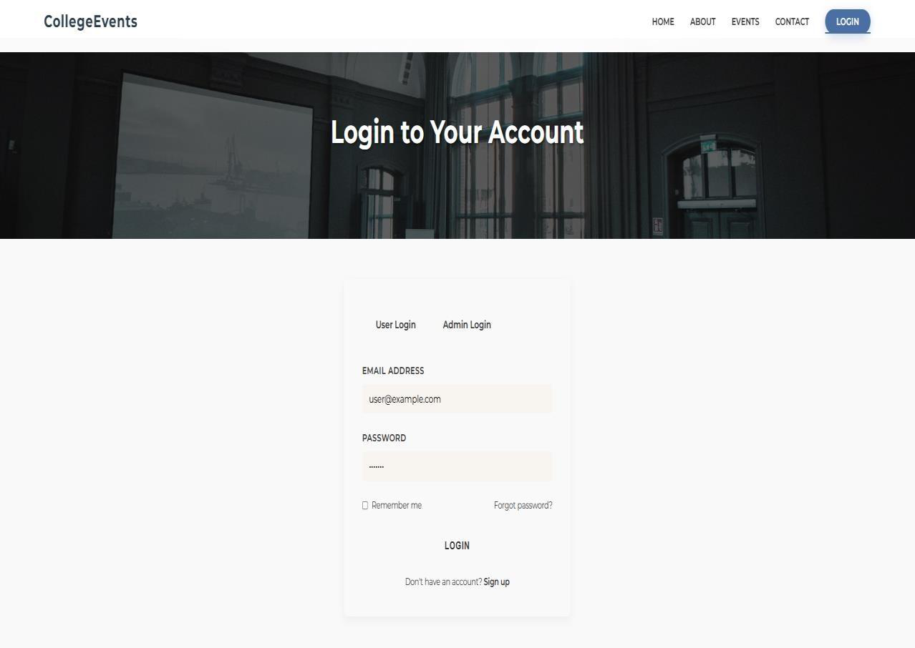

91

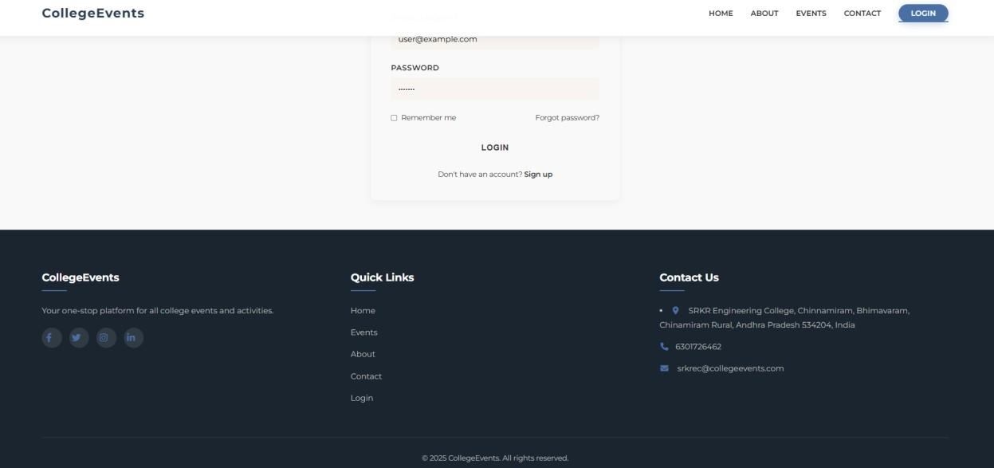

About Us:



92

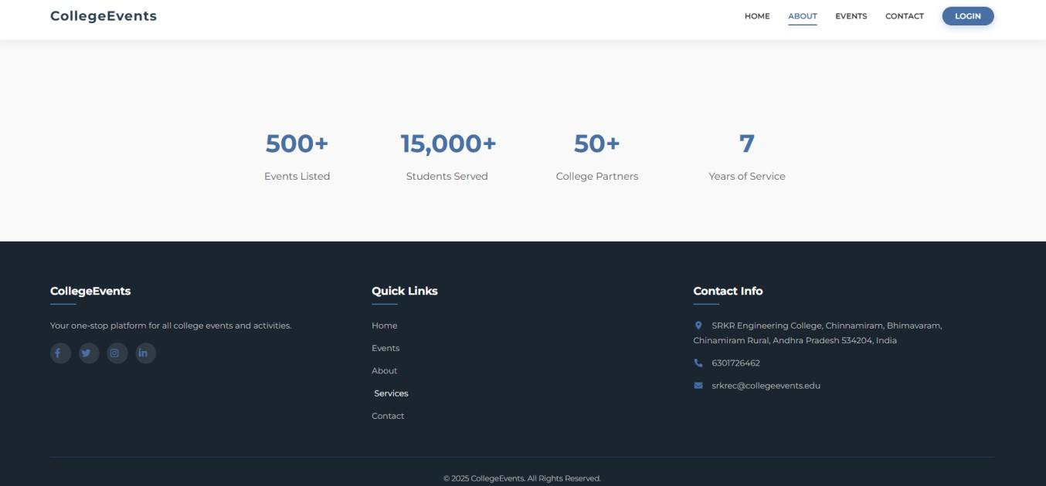

93

Home Page :



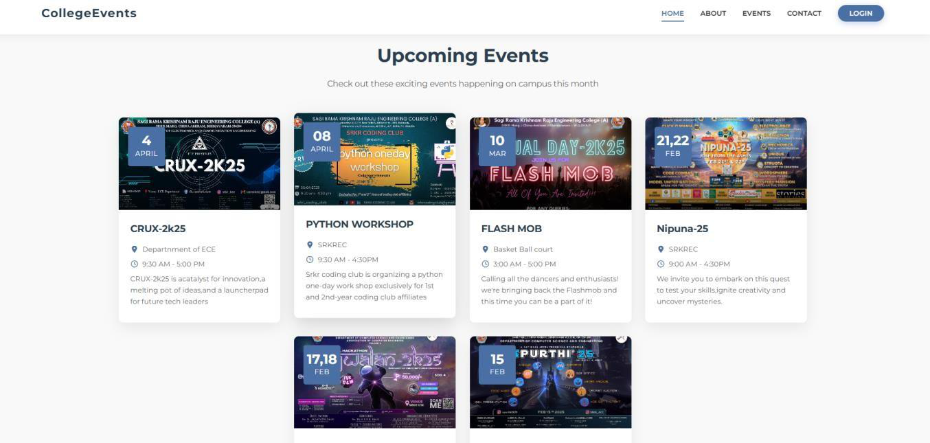

94

Events Page :

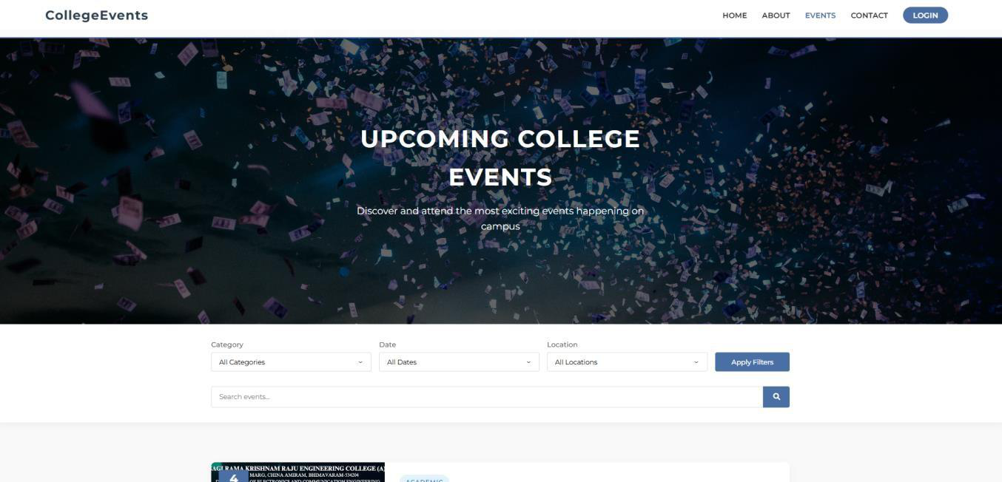

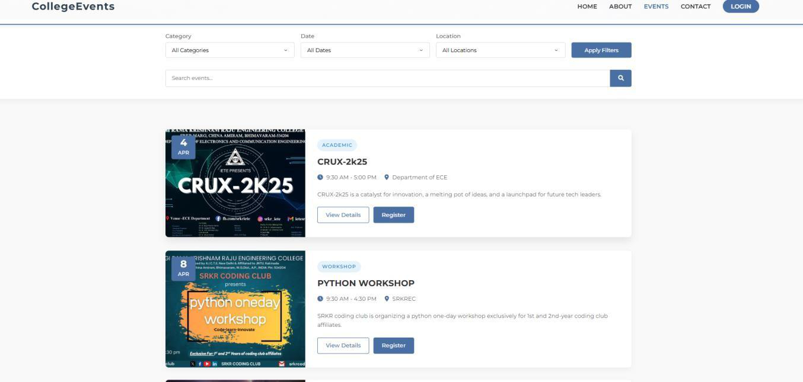

95

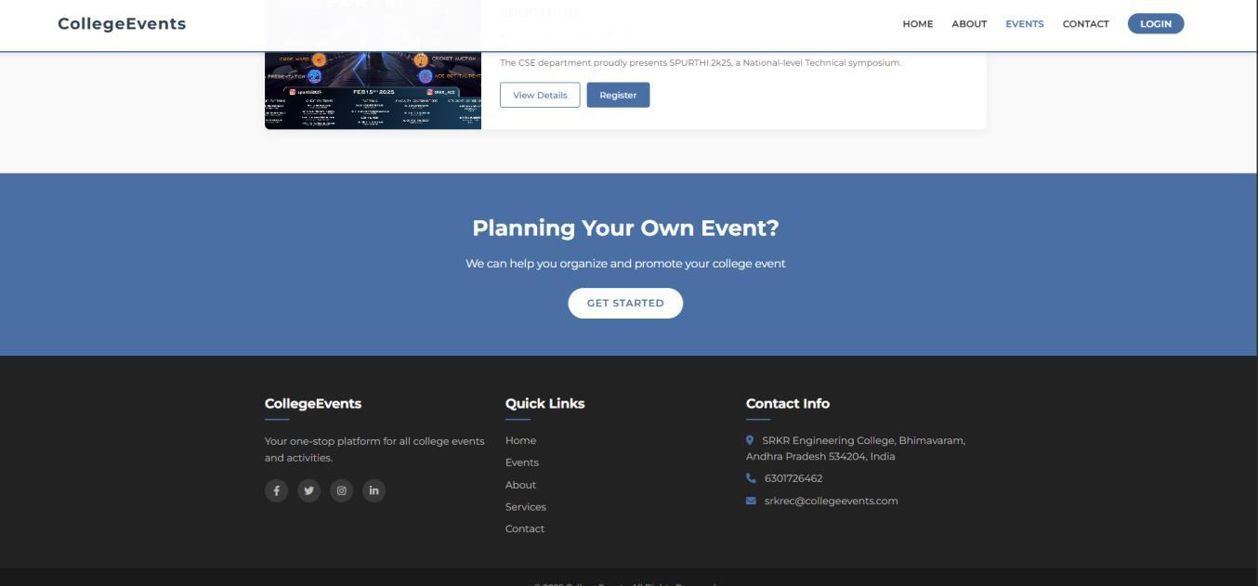

Contact Us :

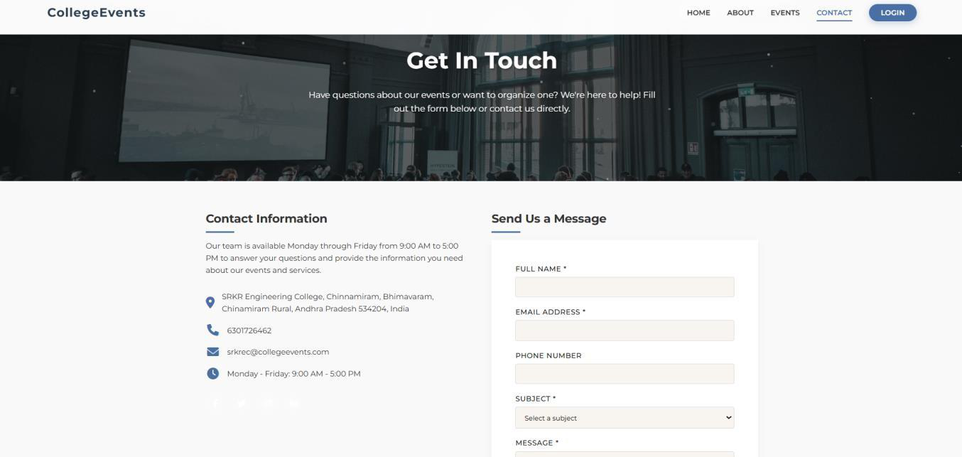

96